Activity 4.1d Software Modeling Introduction (Digital STEAM)
Procedure
- Go to the Autodesk Digital STEAM site at the link below. http://curriculum.autodesk.com/student/public/index/index
- Click Level 1, Digital Study Packet, then Inventor.
- Under User Interface click Primary Environments and view the tutorial. Answer the questions below. Note: Move the cursor away from the video window for a clear view.
  - What are the four Inventor base environments and file extension names?
    - ____________________________
    - ____________________________
    - ____________________________
    - ____________________________

- View the tutorials listed under UI Navigation – UI Navigation 1, UI Navigation 2, and Graphics Window Display. Answer the questions below.
  - Label the features of the user interaction images below.
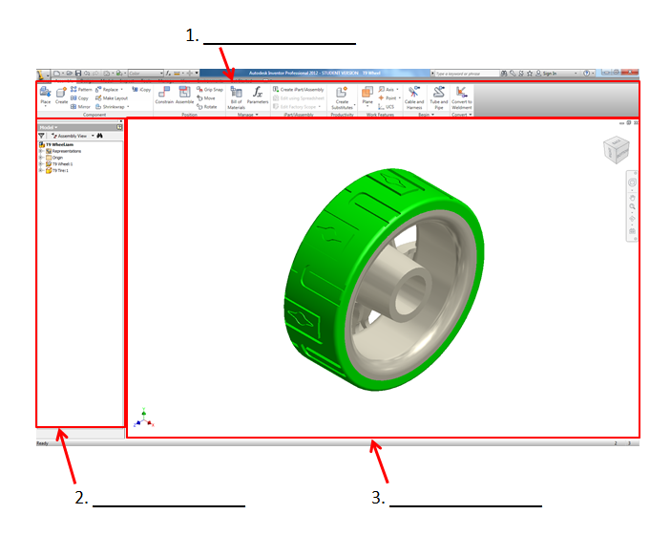

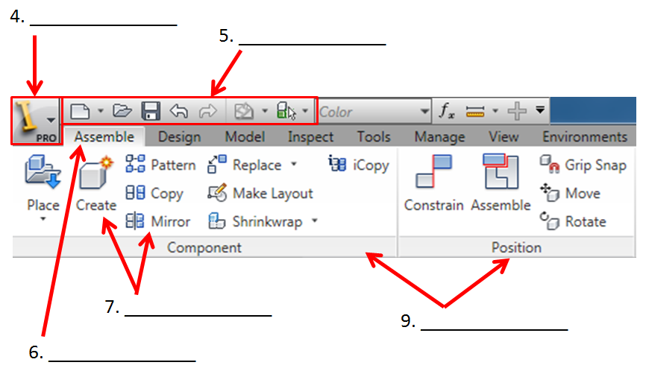
  - Label the Assembly environment below.
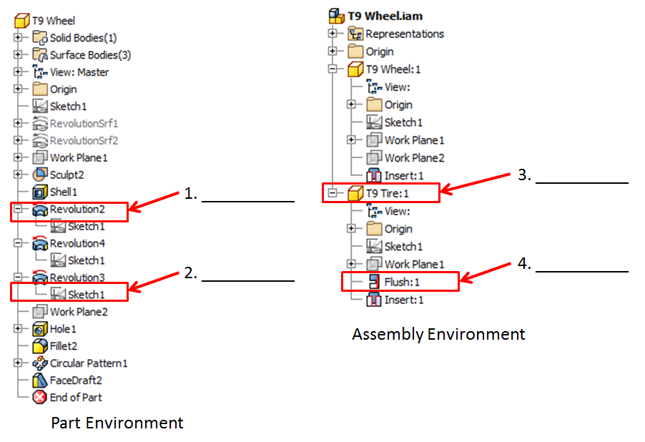
  - How do you display the browser if it has disappeared?

  - How do you edit the display of items in your Quick Access Tool Bar?

- View the tutorial listed under Navigation Control. Answer the questions below.  - Label the navigation control image to the right. | - 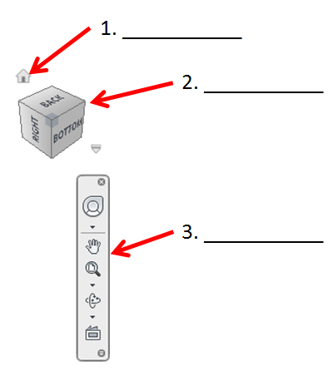
  - Describe the functions available with each of the following function keys.
- F2 __________________________
- F3 __________________________
- F4 __________________________
- F5 __________________________
- F6 __________________________

