Activity 4.1g Model Creation

Procedure
Follow the instructions to create 3D solid models of each of the following objects using the specified method(s) and respond to the prompts.

1. | 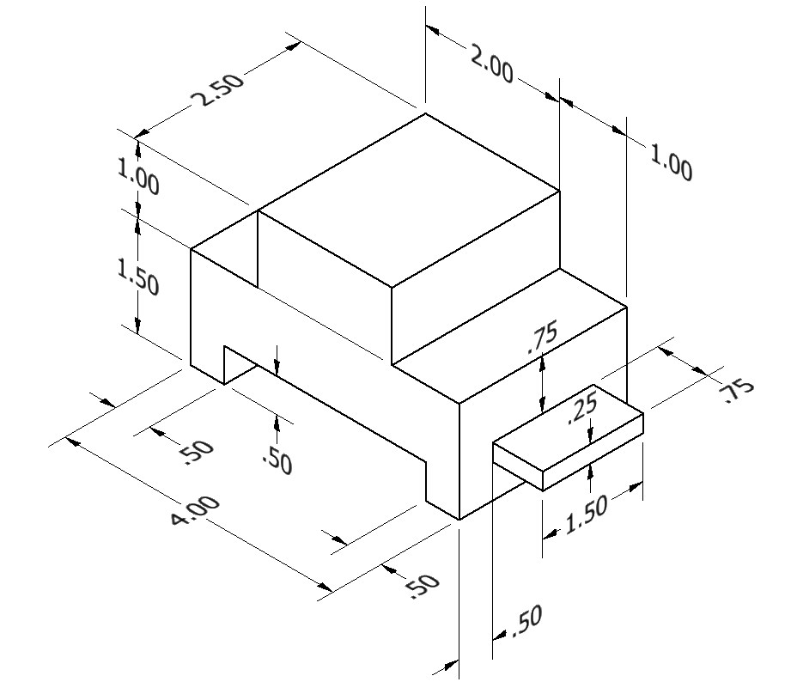
 | All dimensions are in inches.
 | Create a 3D solid model of the object above using the most efficient method.
 | Which method (additive, subtractive, or a combination of additive and subtractive) did you use? Why do you feel it was most efficient?

2. | 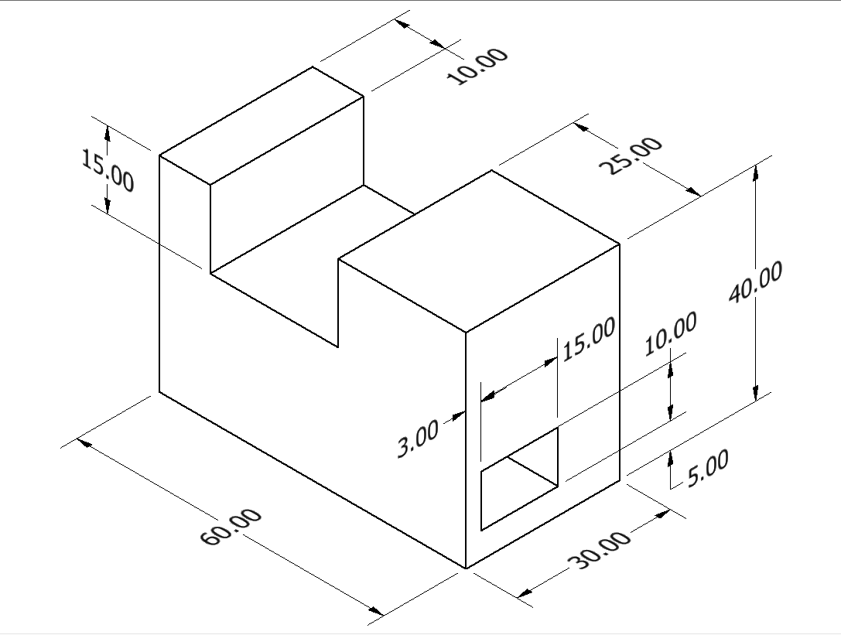
 | All dimensions in mm.
 | Create a 3D solid model of the object above using the most efficient method possible. The hole extends through the part.
 | Describe the method you used to model the object? Why do you feel it was most efficient?

3. | 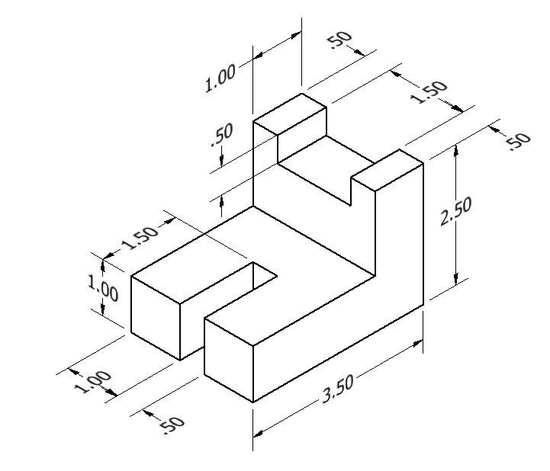
 | All dimensions are in inches.
 | Create a 3D solid model of the object above using only additive procedures.
 | Create a 3D solid model of the object above using only subtractive procedures.
 | Which method (additive, subtractive, or a combination of additive and subtractive) do you feel would be the most efficient method for creating the object? Why?

4. | 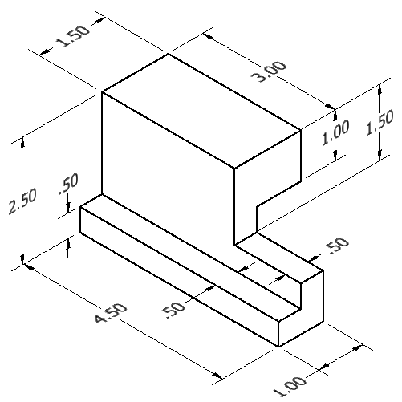
 | All dimensions are in inches.
 | Create a 3D solid model of the object above in the most efficient manner possible.
 | Describe the method you used to create the object.
 | Can you think of a method to create the 3D solid model that would be more efficient? Explain

