Activity 5.2a – Geometric Constraints

- Open the file called Geometric Constraints. Read the instructions above each image in the file and use the Geometric Constraint tools to complete each of the 12 exercises. Your completed sheet should look similar to the sheet pictured.
- Make the geometric constraints visible by choosing the Show Constraints tool in the Constrain panel under the Sketch tab.
- Add your name to the bottom right corner of the sheet. You may use the Text tool in the Draw panel under the Sketch tab to add text to a sketch.
- Save the file as a different name, print it out, and submit it along with this activity to your instructor for evaluation.
CAD file name and location:

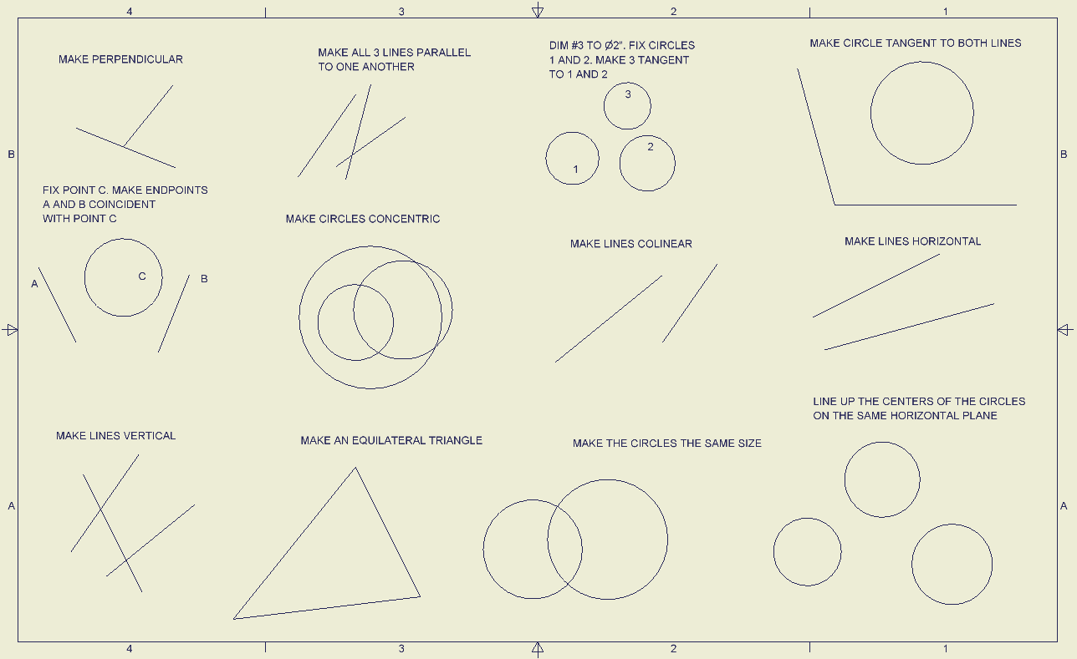
Before

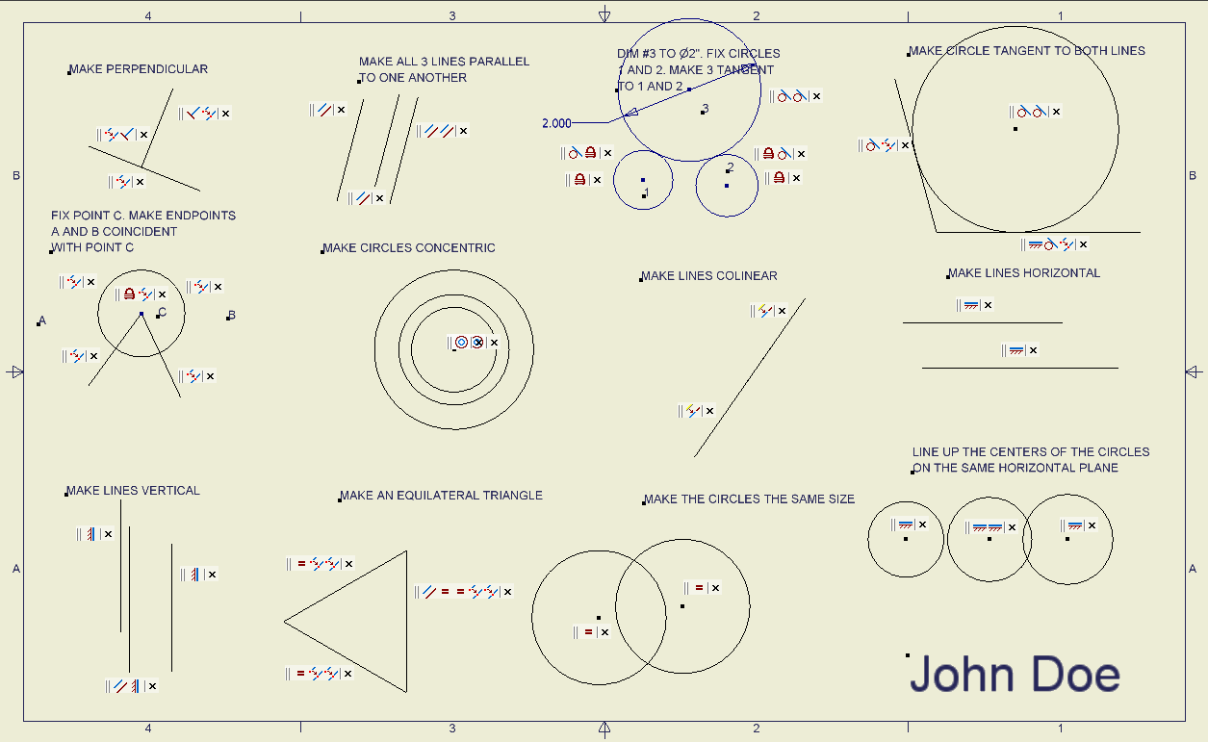
After

Conclusion
- What is a geometric constraint?

- What are the different types of geometric constraints that are applied to sketches, and what are their functions?

- Define “tangent”.

  - Sketch a line tangent to two circles.

  - Sketch three circles such that all circles are tangent to the other two.

- How is a geometric constraint different from a numeric constraint?

