Activity 5.5 CAD Model Features

Tapered Extrusions
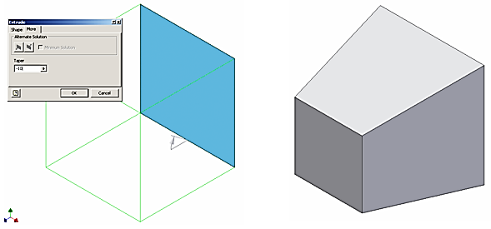
- Extruded objects can be given a positive or negative taper angle. A common example of a tapered extrusion is the design of an ice cube. The sides of the ice cube are tapered with a draft angle to allow the cube to be easily removed from the ice cube tray. Open the file called Extrude-Taper, and extrude the square a distance of 1 inch with a taper angle of -10°. Save the file in your folder.

Intersect Extrusions
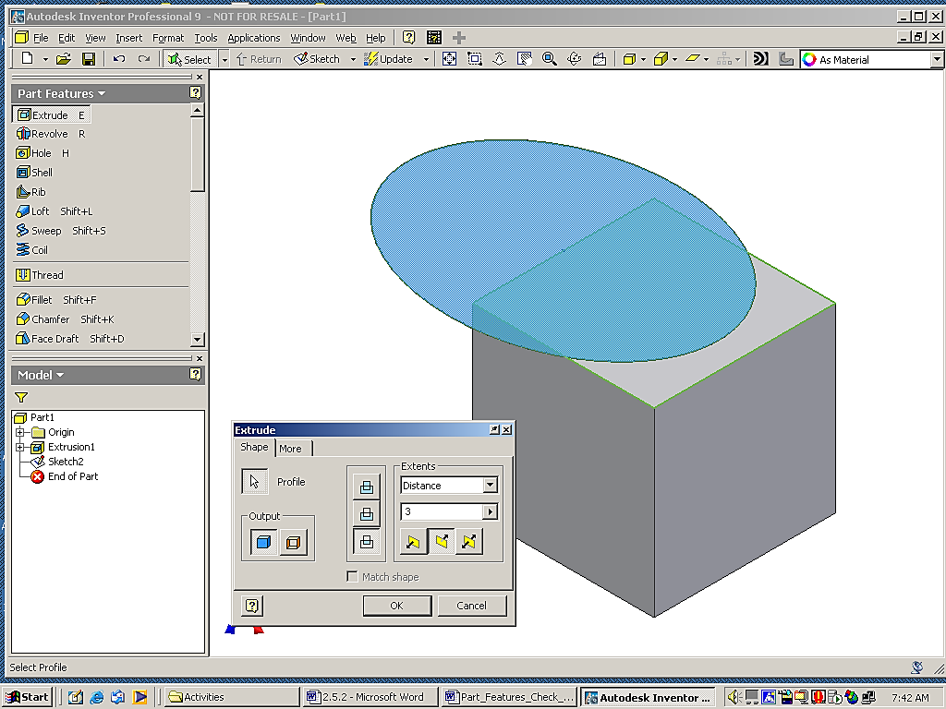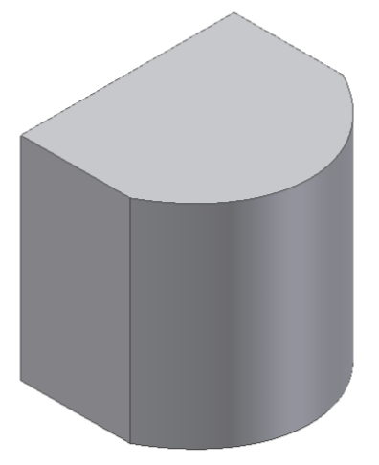
- The intersect extrusion function will perform a Boolean addition and subtraction in one operation. Any part of the sketch profile that overlaps existing geometry will remain. The portion of the sketched profile and the existing geometry that do not overlap will be removed. Open the file called Intersect and perform an intersect extrusion on the sketch all the way through the existing object to observe what takes place. Note that the dialog box may appear different in other versions of Inventor. Save the file in your folder.

Hole
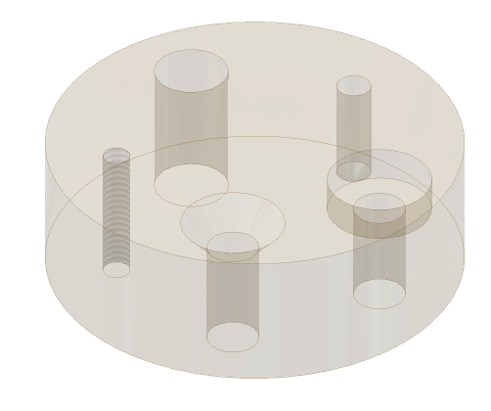
- The Hole function requires a hole center for each instance. Open the file called Drilled Holes. The existing feature is a blind hole, and has been created for you. The following page shows the different function windows that are associated with a counterbore, countersink, threaded hole, and clearance hole. The center of each hole is a point placed in a sketch. All points in a sketch will be auto-selected by the computer when the Hole command is initiated. You will have to hold down the shift key to deselect the hole centers that you do not want – be sure the Centers button is depressed. Work your way around the block in a clockwise direction initiating the Hole function, selecting the appropriate hole center, and identifying the type of hole feature that is needed. Use the diagrams for each hole shown below to gather the necessary information. Note: a shared sketch will not disappear after the first feature is created. Save the file in your folder.

Through (THRU) Hole
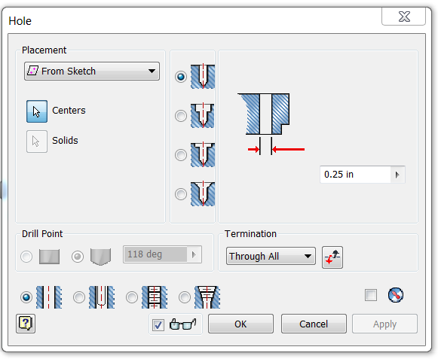 | 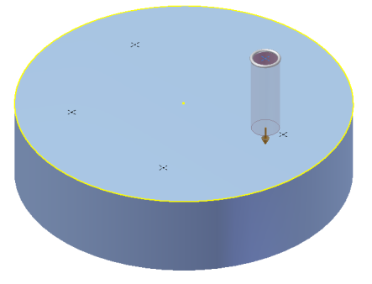
Counterbore
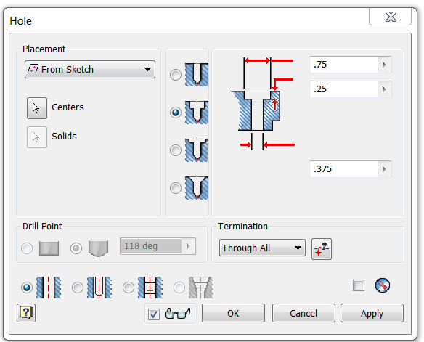 | 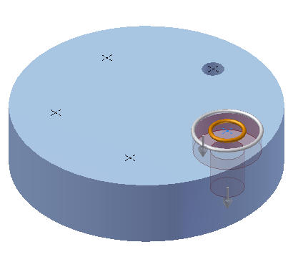
Countersink
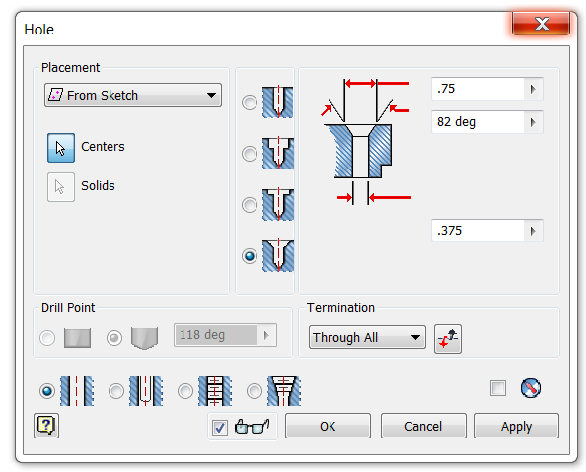 | 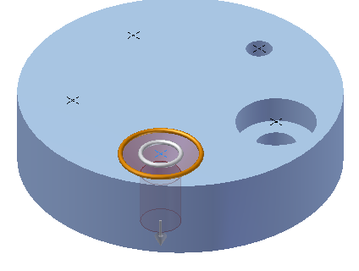
Threaded Hole
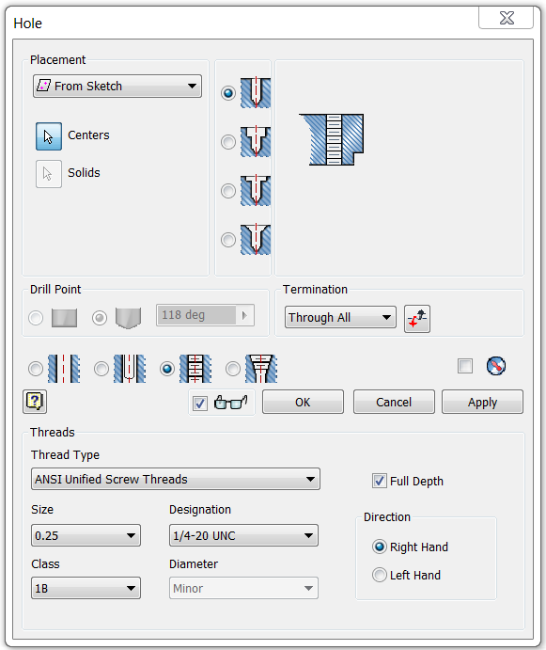 | 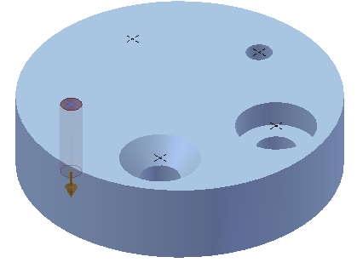
Clearance Hole
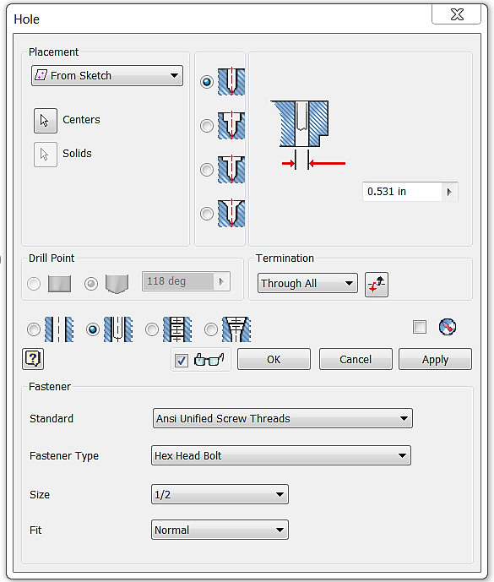 | 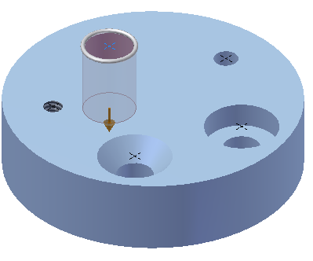

Revolve
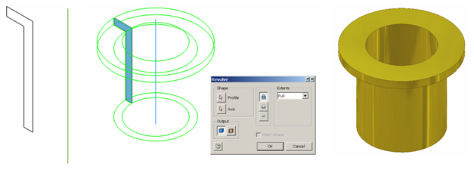
- Revolve is a function that allows the user to extrude a closed profile around a fixed axis up to 360°. The axis can be part of the profile, an existing edge on a part, or one of the axes of the Cartesian coordinate grid. Grid axes may be selected from the Origin folder located in the Browser bar. Open the file called Bushing. Use the revolve function to revolve the sketch around the existing axis a full 360°. Save the file in your folder.

- Use the Revolve function to create the Rubber Handle Sleeve part for the Button Maker as shown in the dimensioned drawing below. Remember to create only half of the section and revolve it a full 360 degrees. You can include a line in the sketch to act as the axis of revolution. Save the file as RubberHandleSleeveYourInitials.ipt.
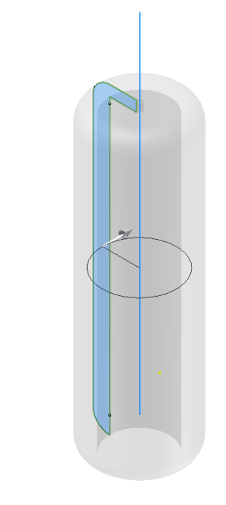 | 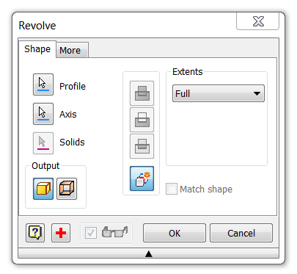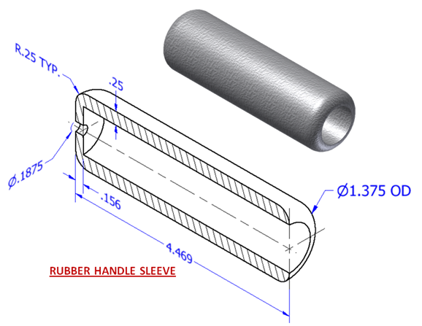

- Use the Revolve tool to create a 3D solid CAD model for the Upper Die Center for the Button Maker using actual measurements or the dimensioned pictorial. The hole identified with the thread note is a single hole. Save the part file as UpperDieCenterYourInitials.ipt.
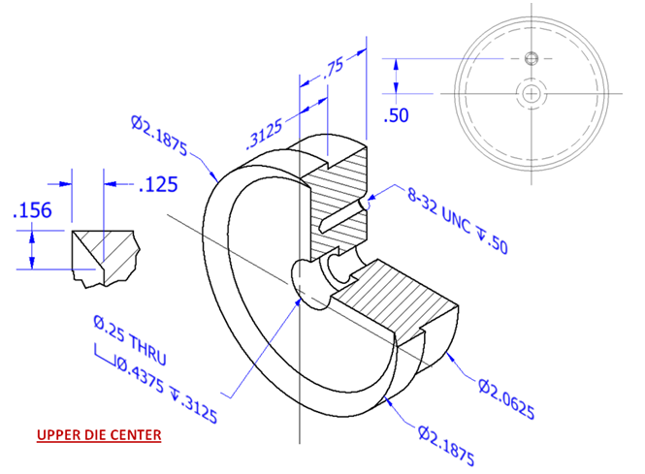
- Create a 3D solid model of an axle for the Automoblox vehicle using the Revolve tool. Use your measurements or the dimensioned pictorial drawing. Then sketch a rectangle on the end of the axle and extrude cut to the stated depth. Save the file as AxleYourInitials.ipt.

Loft
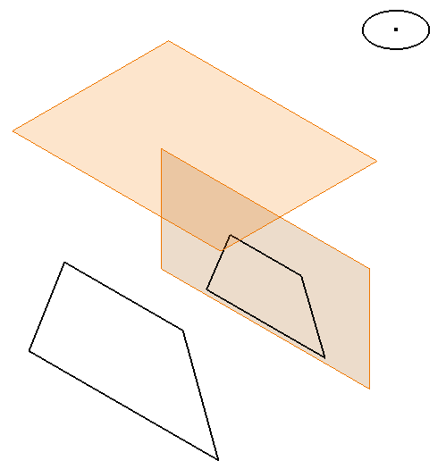 | 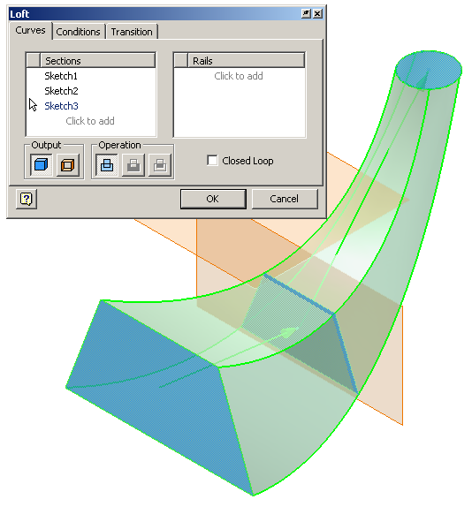

- The loft function allows the user to create a solid or surface by blending two or more shapes that are located on different planes. Open the file called Loft. Use the Loft function to blend the three profiles into one solid object. Save the file in your folder.

Circular Pattern

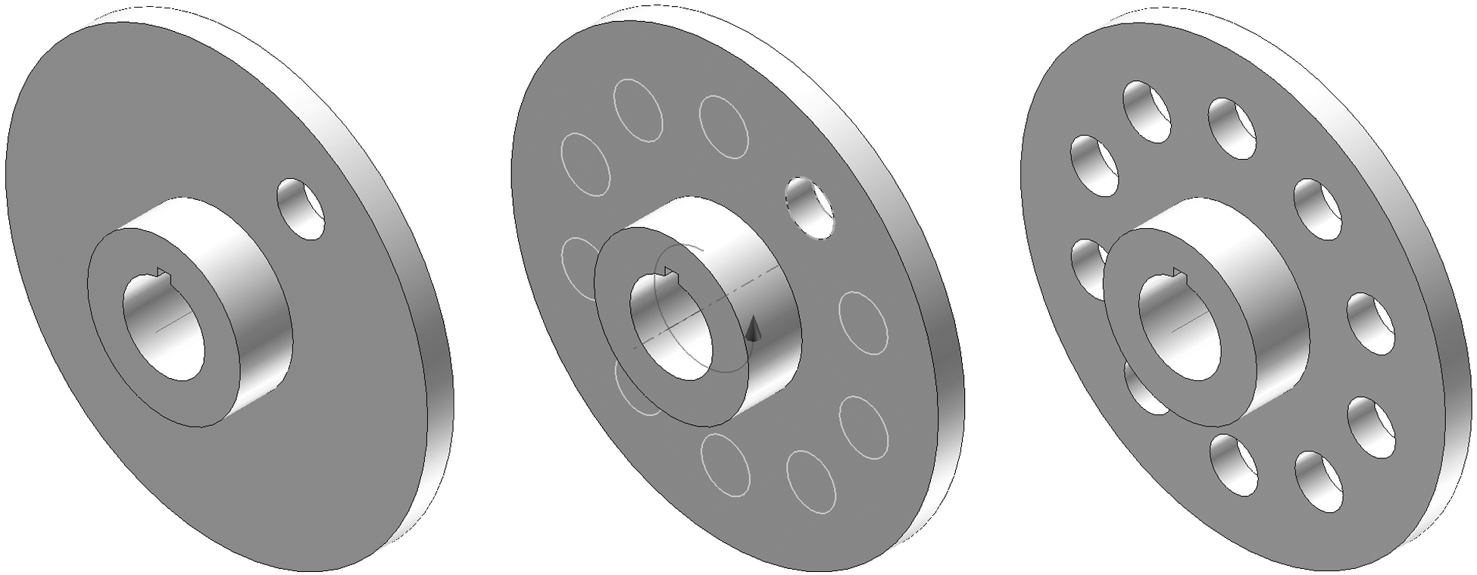

- The pattern function allows the user to make multiple copies of an existing feature (as opposed to a sketch line as discovered in Activity 5.2 Making Sketches in CAD) in one of three ways. A circular pattern is often used to array a hole around a center axis. An edge on an existing feature can also serve as the center axis. Open the file called Circular Pattern, and use the circular pattern function to copy the existing hole on the flange plate a total of 10 times (the first hole must be represented in the count) around the existing work axis. Save the file in your folder.

- Model the Upper Die Pressure Ring for the Button Maker using the dimensioned drawings below. Use the Revolve and Circular Pattern tools. Save the file as UpperPresRingYourInitials.ipt in your Button Maker project folder.
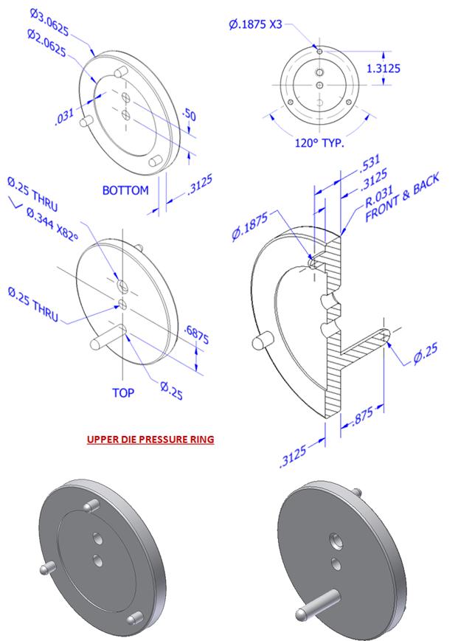

Rectangular Pattern

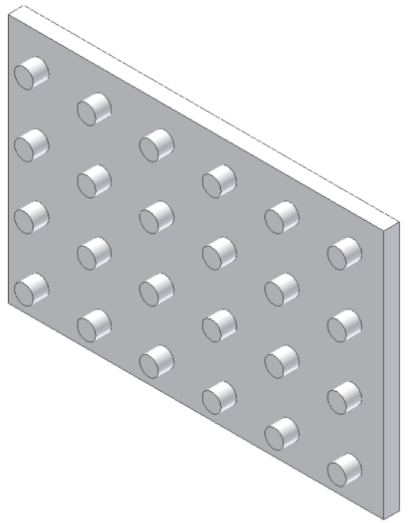

- The rectangular pattern function allows the user to make copies of an existing feature in one direction or two directions simultaneously. Existing edges or the axes of the Cartesian coordinate grid must be selected to identify the desired direction(s). Open the file called Rectangular Pattern. Use the rectangular pattern to copy the existing cylindrical extrusion six times in the horizontal direction and four times in the vertical direction. Save the file in your folder.
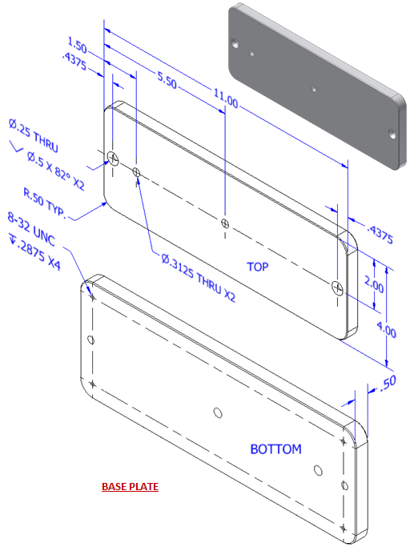
- Create the Base Plate for the Button Maker using the dimensioned pictorial below. Create one of the holes in the bottom of the plate into which the rubber feet are screwed. Then use the Rectangular Pattern tool to pattern four holes on the bottom. Next create one of the through drilled (straight) holes and use another rectangular pattern to create the second drilled through hole. Then create the countersink holes. Save the file as BasePlateYourInitials.ipt.

Fillet
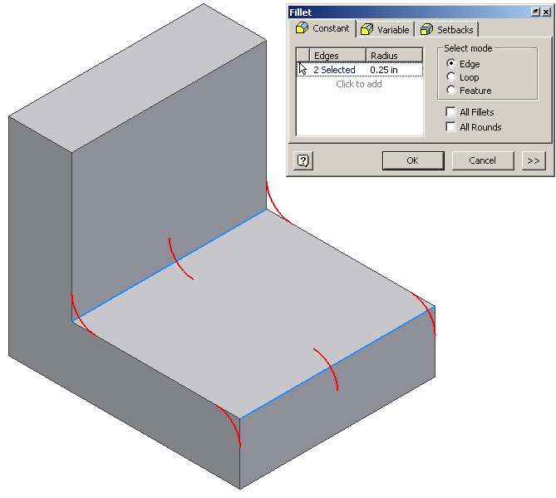
- Fillet is a function that allows the user to create a rounded blend where two surfaces meet to form an edge. It should be noted that on an exterior corner, the resulting feature is known as a round. On an interior corner, the resulting feature is known as a fillet. Open the file called Fillets Chamfers. Use the fillet function to apply a .25 radius to the corners shown above. This model will be used in the next exercise.

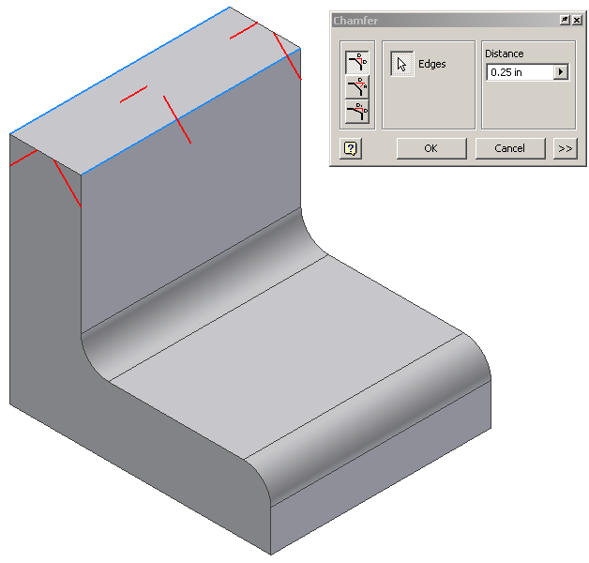
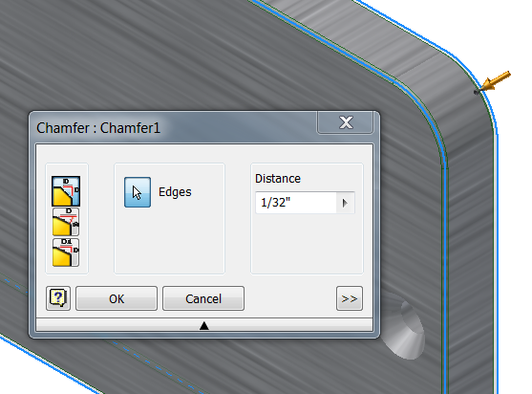
Chamfer
- Chamfer is a function that allows the user to apply an angle surface where two existing surfaces meet to form an edge. Open your file called Fillet Chamfers. Use the chamfer function to apply a .25 inch x 45° chamfer to the edges shown above. Save the file in your folder.

- Use the Chamfer function to apply a 1/32” chamfer to all of the edges of the Button Maker Base Plate that you created earlier.

Mirror
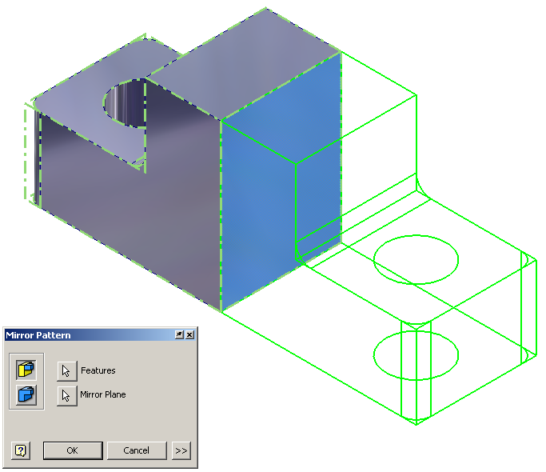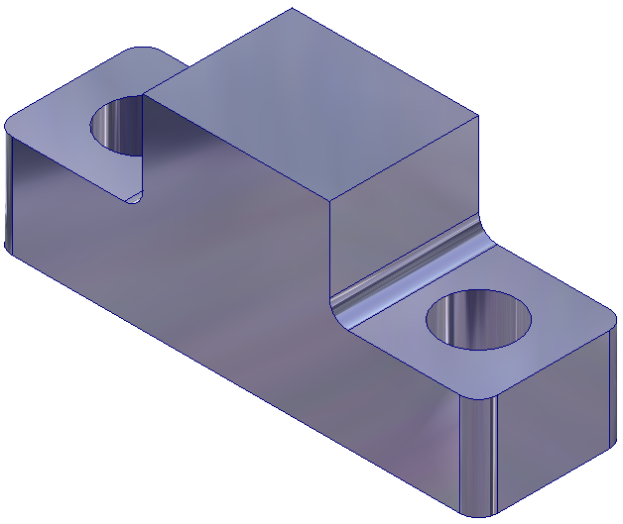

- Mirror is a function that allows the user to create a mirror image of existing geometry. This function requires an existing feature(s) and a surface or work plane to serve as the mid-plane of symmetry. Open the file called Left Half. Use the mirror function to add a duplicate mirror image of the existing geometry on the other side of the right face of the object. Save the file in your folder.

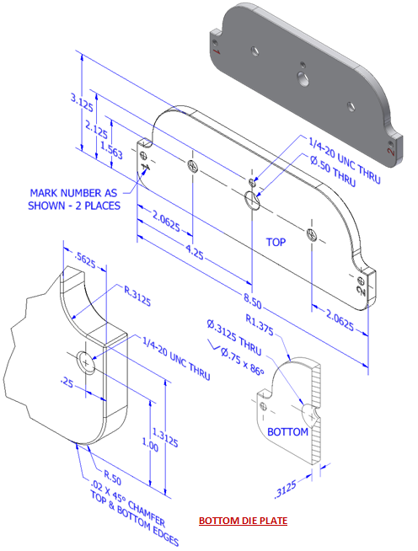
- Create the Bottom Die Plate for the Button Maker by creating half of the part and then mirroring it across the center line. Add the large center hole but do not include the other holes at this time. Save the part as BottomDiePlateYourInitials.ipt.

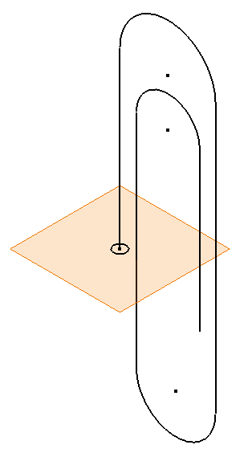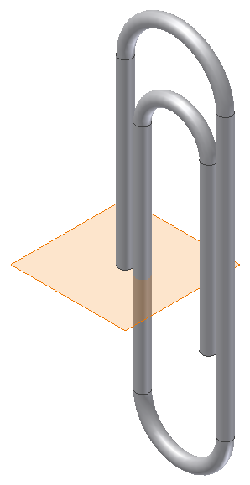

Sweep
- The sweep function allows the user to extrude a closed profile along a path. The path may be open or closed. The profile and the path must exist as two separate sketches. Open the file called Paper Clip. Use the sweep function to extrude the circle along the existing path to create the form of a paper clip. Save the file in your folder.

