Activity 6.1 Visual Design Principles
and Elements Identification
The purpose of this activity is to identify the visual design elements that appear in your environment and then identify the visual design principles by which they were arranged.

- Locate five man-made items at home, school or elsewhere in your environment that are visually interesting. Take a photograph of each item. If it is not possible to take a photograph, sketch the item and shade it with colored pencils to closely represent the object.
- Document your visual analysis on Activity 6.1a Visual Design Principles and Elements Matrix. Attach your image to the matrix or card and include your name, the name of the product, and identify the visual design principles and elements that are evident in that product. [Also note and explain any obvious disregard for a principle of design. For example, if a design appears chaotic and lacks unity, note this and explain why.]
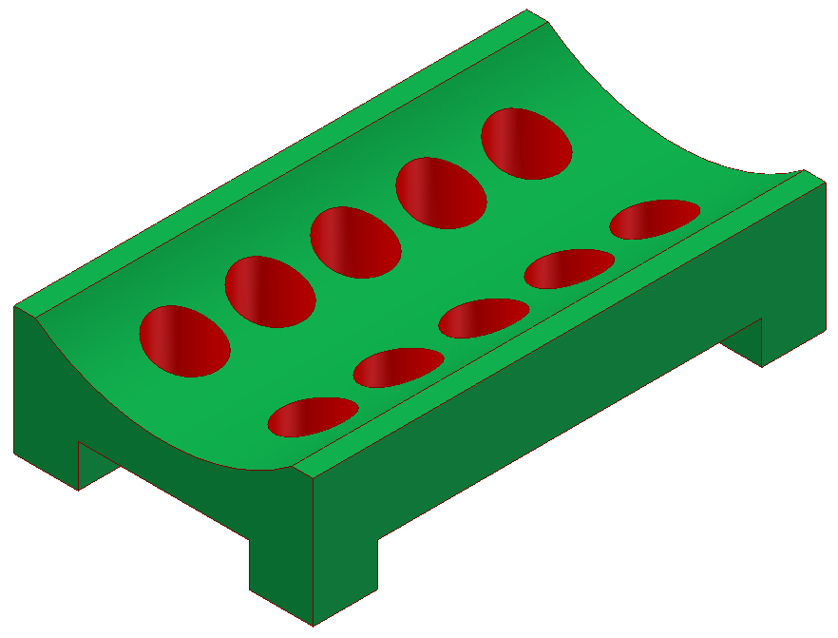
Example of a matrix completed on this Soap Dish.

 |  | Elements of Design
 |  | Point | Line | Color | Value | Shape | Form | Space | Texture
 | Description of Use of Element of Design | n/a | Straight edges and curved top surface | Bright green and red | n/a | Geometric shapes - rectangular and circular | Solid forms created by rectangles and circles | Space around circular openings in top. Depth evident in holes. | Smooth
Principles of Design | Balance |  |  |  |  | Formal Balance created by symmetry | Formal Balance created by symmetry | Formal Balance created by symmetry
 | Emphasis |  |  | Red color emphasized against green background
 | Contrast |  | Curved top edge contrasts with straight edges on sides | Red and green colors contrast
 | Rhythm |  |  |  |  | Regular rhythm created by repeated use of circular holes
 | Proportion |  |  |  |  | All shapes seem proportional and appropriate for function | All forms seem proportional and appropriate for function
 | Unity |  |  |  |  | Consistent use of geometric shapes |  |  | Consistent smooth texture
 | Economy |  | Simple lines |  |  | Simple shapes – no extraneous elements

Conclusion
- How are visual design principles and elements utilized in a design?

- Identify a product that you feel is aesthetically pleasing. What is it about the product that you find appealing?

- Identify a product that you don’t like the appearance of and identify the visual design principles and elements that lead to this feeling.

- Identify the visual design principles and elements that were not used appropriately in some of the products shown.

