Activity 7.2 Holes and Sectional Views
- In Inventor, create a solid model of drill block below. Then create a fully dimensioned multi-view part drawing showing the front view on a size A paper (delete ANSI). Save the files as Drill Block in your unit seven folder. We will complete another step on this drawing as a class then print and turn in for credit.
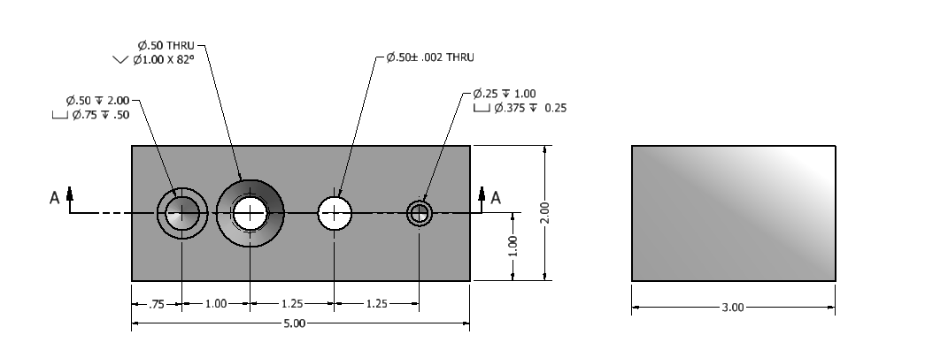

- Create the object shown below as a solid CAD model. Then create a fully dimensioned multi-view drawing to document the part, save the CAD files as Arbor Press Base in your unit 7 folder. Print and turn in the drawing.
