Activity 7.3 Tolerances

- Study the drawing below to identify specified tolerances.
Letter | Tolerance Type | Tolerance

  - Circle each dimension that has a tolerance associated with it.
  - Label each identified tolerance with a separate letter, A through D.
  - In the table, record the letter of each tolerance identified on the part drawing, the type of tolerance (limit dimensions, unilateral tolerance, or bilateral tolerance), and the amount of tolerance (a number representing the total allowed dimensional variation).

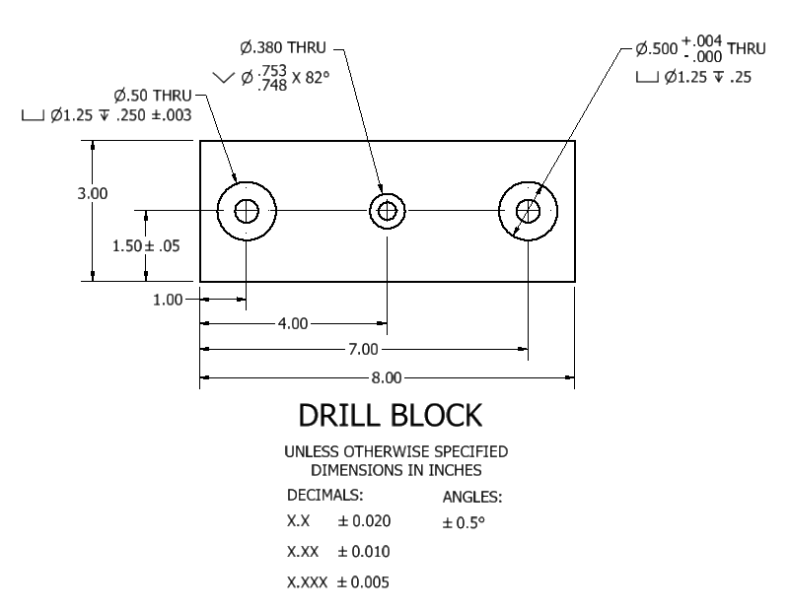

- Open the drill block drawing that you created in Activity 7.2 Sectional Views. The drill block drawing is shown below.

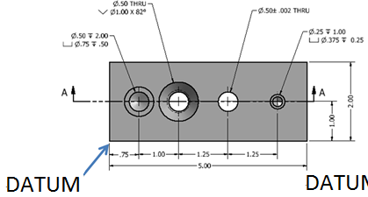

Edit the dimensions to show specific tolerances to the following dimensions. Note that instructions for including tolerance specifications on an Inventor drawing are given below.
  - A bilateral (symmetric) tolerance of 0.10 inches for the overall length, width, and depth.
  - Stack limit dimensions to locate the holes along the depth dimension (2 in.) such that the dimension can vary between the dimension given and 0.03 inches larger.
  - To better control the hole locations, use datum dimensioning for the dimensions along the long dimension (5 in.). Note that the datum location is shown on the drawing above.
  - A unilateral (deviation) tolerance of +.003 inches for the counter bore diameter on the 0.25 inch diameter hole. Change the precision of the counter bore diameter to show three digits to the right of the decimal place.
  - A bilateral (symmetric) tolerance of 0.002 on the 0.50 inch diameter counter sunk hole.

Showing Tolerances in Inventor
You can edit dimensions and include tolerances in both a part file and a drawing file. For now, we will simply add tolerances to the drawing (not the part). One option is to simply change the dimension text to include the tolerance. However, it is not possible to add stacked text. A better way to include a tolerance in a dimension or hole is to change the precision and tolerance of the dimension itself.
To include a tolerance in a dimension on a drawing in Inventor.
- Select the dimension.
- Right click and choose Edit.
- Select the Precision and Tolerance tab.
- Check the Override Displayed Value box.
- Select the Tolerance Method.
- Select the precision (number of decimal places).
- Input the required upper/lower values.
- Depress the OK button.
To include a tolerance in a hole note on a drawing in Inventor.
- Select the hole note.
- Right click and choose Edit Hole Note.
- Depress the Precision and Tolerance button.
- Uncheck the Use Global Precision box.
- Depress the additional options arrow button (bottom right).
- Select the precision (number of decimal places) for each dimension value using the drop-down menus.
- Use the check boxes to choose the dimension to which you will add a tolerance. Choose the tolerance method and precision of the tolerance value(s).
- Depress the OK button.

