Project 8.1 Model A Button Maker

Introduction
Interpreting dimensioned drawings is an important engineering skill. Using drawings to create a computer model of a part or product is also important. Communicating information effectively allows a group of people to function as a design team.

In this project you will further develop your modeling skills and your ability to use a computer as an efficient communication tool. The skills that you learned earlier in this course will be systematically applied to model and sub-assemble the parts of the Button Maker. These sub-assemblies will be used later to create the final assembly and an assembly drawing for the Button Maker.

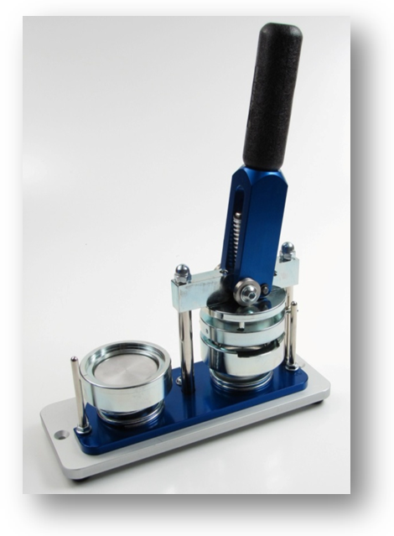 | 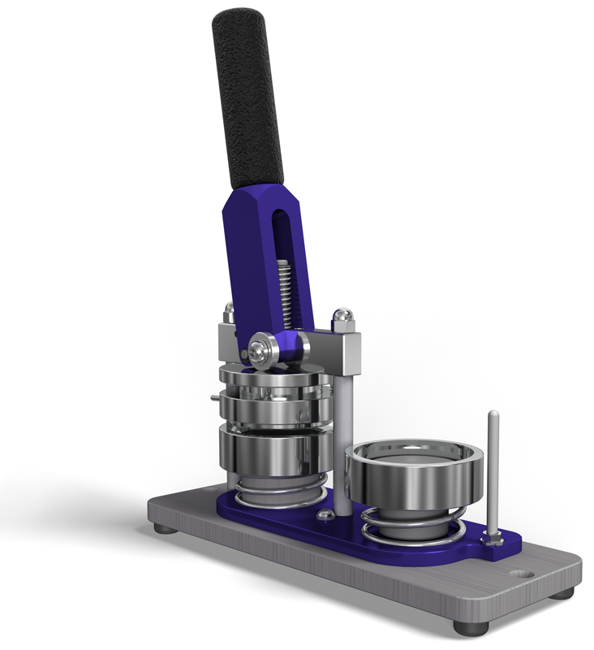
Equipment
Computer with 3D CAD solid modeling program
Engineering notebook
CAD Files (Teacher will provide as applicable)
Procedure
- Model the button maker parts required as noted by the word Model in the Required column of the following table. You may have already modeled some of these parts in earlier activities. Crete models of other parts (Optional) as required by your instructor.
- Create subassemblies as indicated in the table and drawings below. Use the parts you have created and/or part model files provided to you.

Sub Assembly | Item | PART NUMBER | Required | Optional
Bottom Press Assembly |  |  | Assemble
 | 1 | BASE BEARING |  | Model
 | 2 | 1/4 – 20 CAP NUT |  | Model
 | 3 | SMALL SNAP RING |  | Model
 | 4 | HANDLE PIVOT PIN |  | Model
 | A | BASE SUB-ASSEMBLY A | Assemble
 | B | LOWER DIE SUB-ASSEMBLY B | Assemble
 | C | HANDLE SUB-ASSEMBLY C | Assemble
 | D | UPPER DIE SUB-ASSEMBLY D | Assemble
Base Sub-Assembly A |  |  | Assemble
 | 1 | BASE PLATE | Model
 | 2 | RUBBER FOOT | Model
 | 3 | 8-32 X 3/8 UNC SCREW |  | Model
 | 4 | VERTICAL SUPPORT | Model
 | 5 | 5/16-18 HEX NUT |  | Model
 | 5 | 5/16-18 X 9/16 BUTTON CAP SCREW |  | Model
 | 6 | RUBBER HANDLE SLEEVE | Model
 | 7 | METAL HANDLE INSERT |  | Model
 | 8 | 7/16-14 X 1 3/8 SOCKET SET SCREW |  | Model
Lower Die Sub-Assembly B |  |  | Assemble
 | 1 | BOTTOM DIE PLATE | Model
 | 2 | 5/16-18 HEX NUT |  | Model
 | 3 | SEQUENCE LEVER ARM |  | Model
 | 4 | ¼ WASHER |  | Model
 | 5 | ¼-20 X 5/16 BUTTON CAP SCREW |  | Model
 | 6 | LOWER DIE 1 OUTER RING |  | Model
 | 7 | LOWER DIE 1 CENTER |  | Model
 | 8 | ¼-20 X ¾ SOCKET HEAD SCREW |  | Model
 | 9 | LOWER DIE 2 CENTER |  | Model
 | 10 | LOWER DIE 2 OUTER RING |  | Model
 | 11 | LOWER DIE 2 SPACER |  | Model
 | 12 | BOTTOM DIE SPRING |  | Model
Handle Sub-Assembly C |  |  | Assemble
 | 1 | HANDLE BODY | Model
 | 2 | ROLLER SPACER |  | Model
 | 3 | ROLLER INNER BEARING |  | Model
 | 4 | ROLLER OUTER BEARING |  | Model
Upper Die Sub-Assembly D |  |  | Assemble
 | 1 | UPPER DIE CENTER SUPPORT |  | Model
 | 2 | LARGE SNAP RING |  | Model
 | 3 | HANDLE RETENTION PIN |  | Model
 | 4 | UPPER DIE CENTER PIN |  | Model
 | 5 | UPPER DIE SPRING |  | Model
 | 6 | UPPER OUTER RING |  | Model
 | 7 | UPPER DIE PRESSURE RING | Model
 | 8 | #8-32 X 0.7 SCREW |  | Model
 | 9 | UPPER DIE CENTER | Model
 | 10 | ¼-20 X 1 3/16 SOCKET HEAD SCREW |  | Model

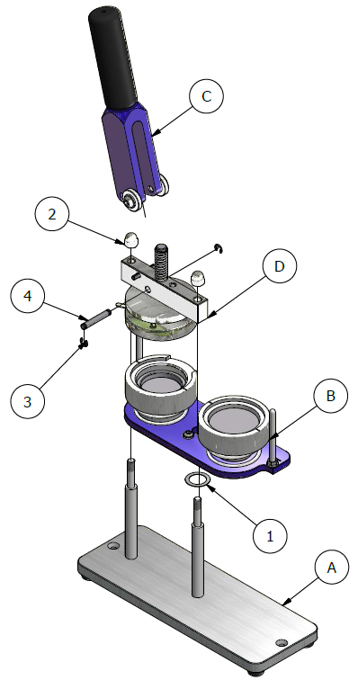
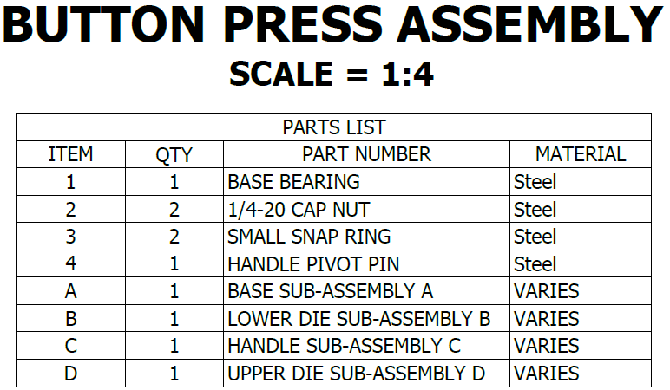
Button Press Tolerances
All parts have the following tolerances:
X.X = +/- .020
X.XX = +/- .010
X.XXX = +/- .005

  - Model and assemble the following subassembly using the drawings provided.
 | 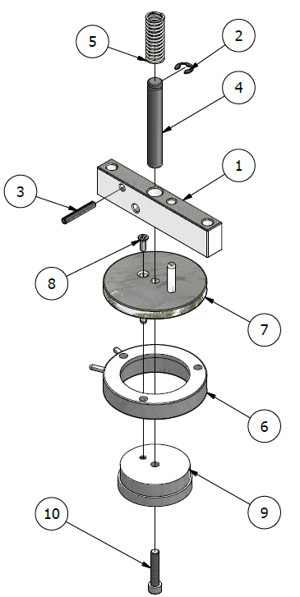
 | 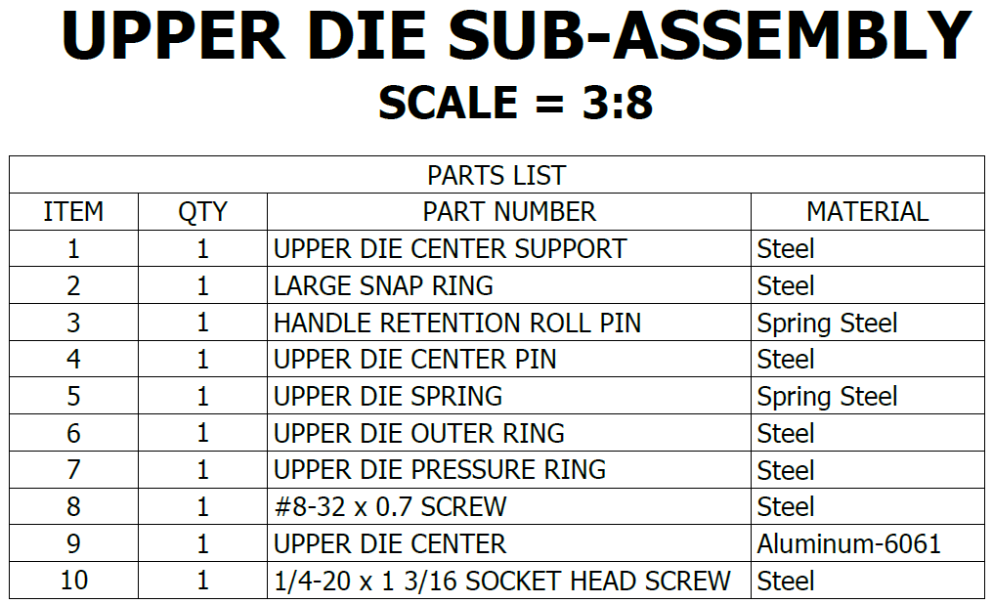
 |  | 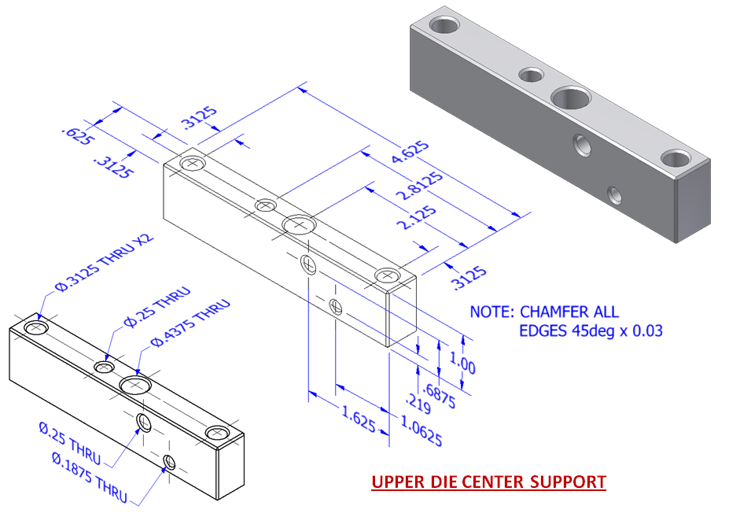
 |  | 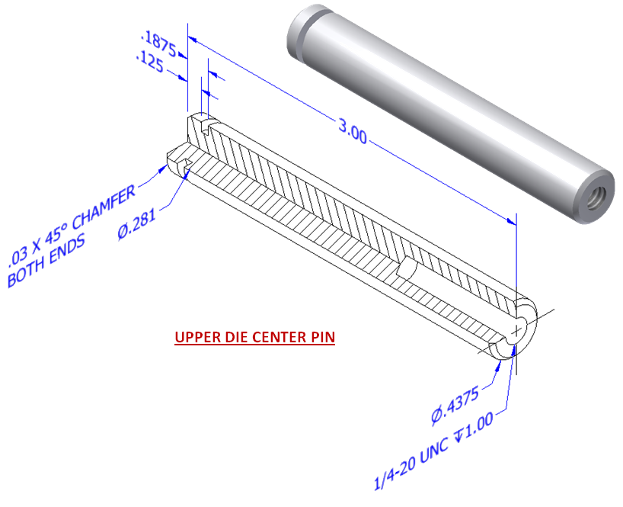
 | 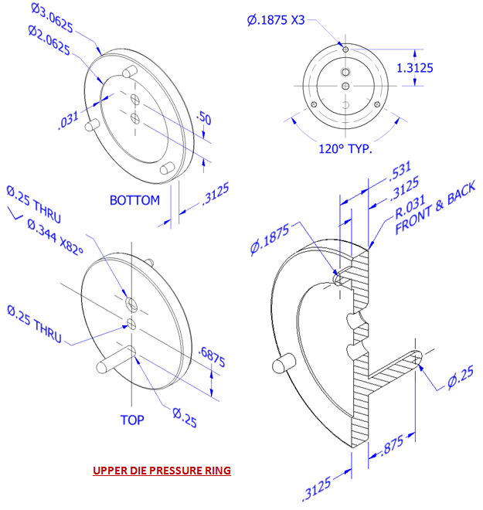
 | 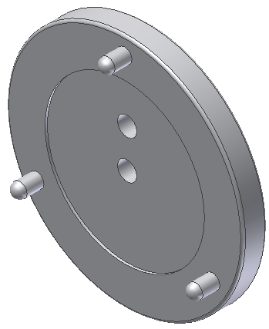 |  | 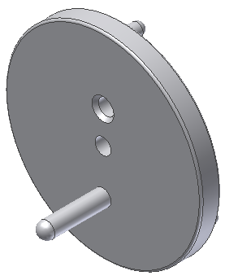
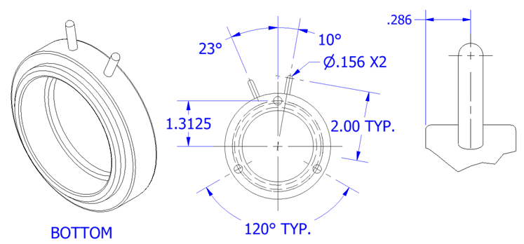
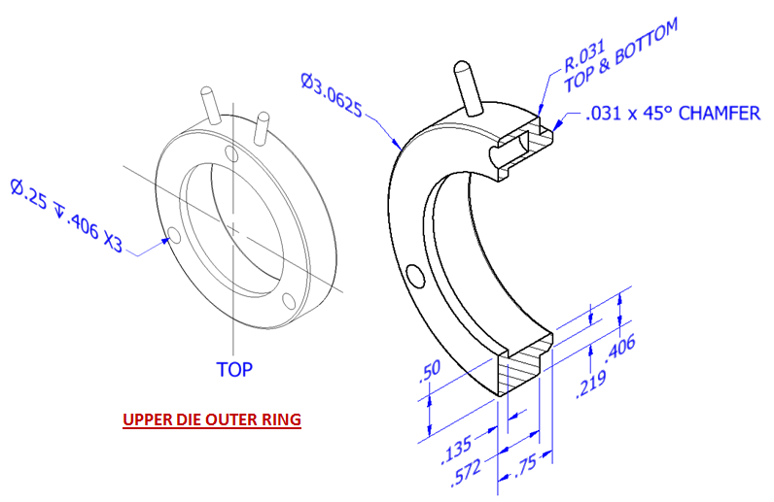
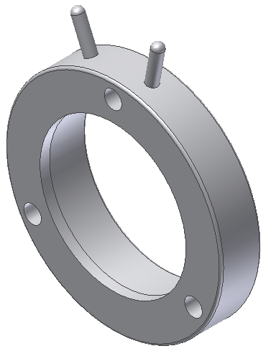 |  |  | 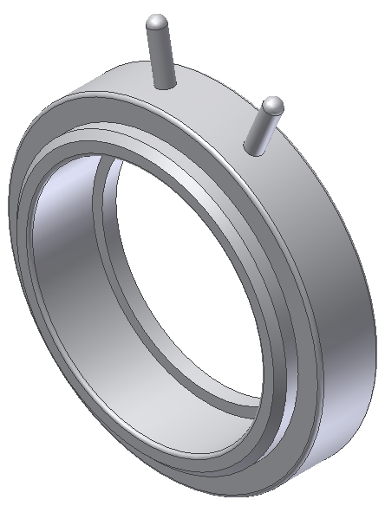
 | 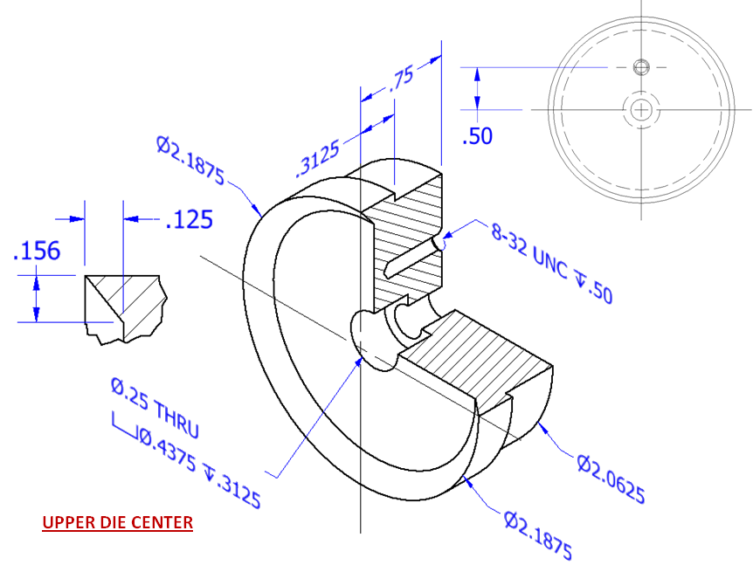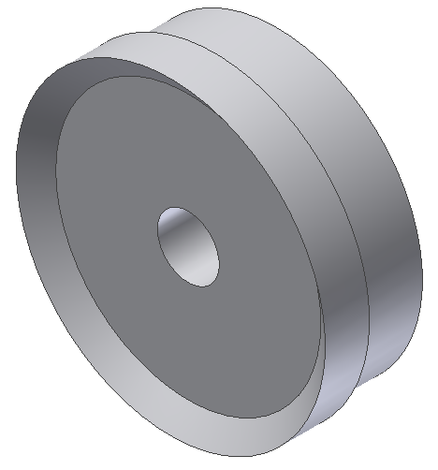

  - Model and assemble the following subassembly using the drawings provided.
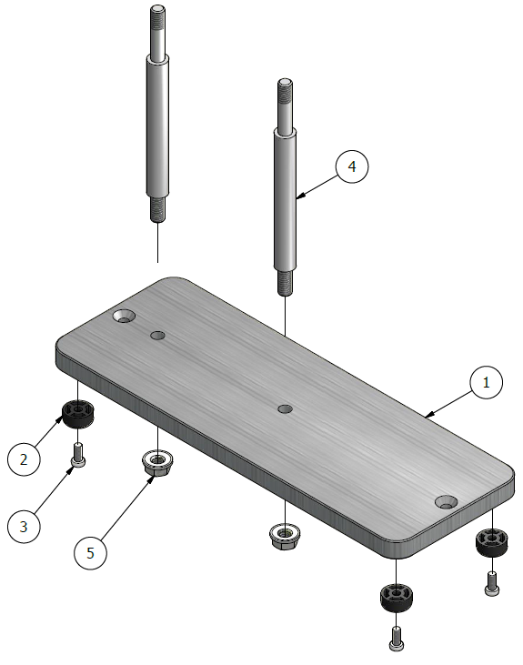
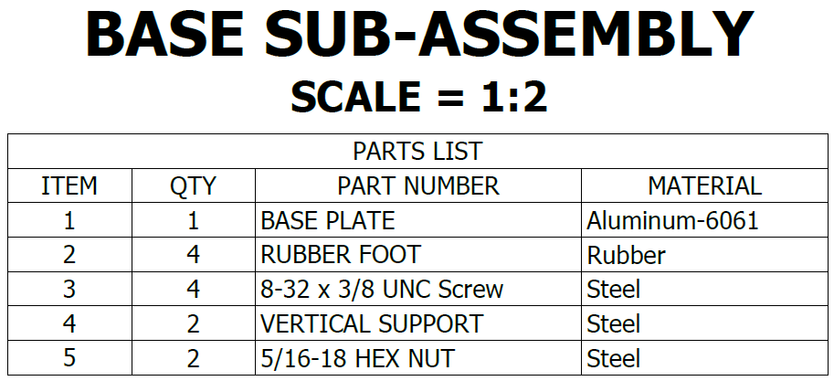

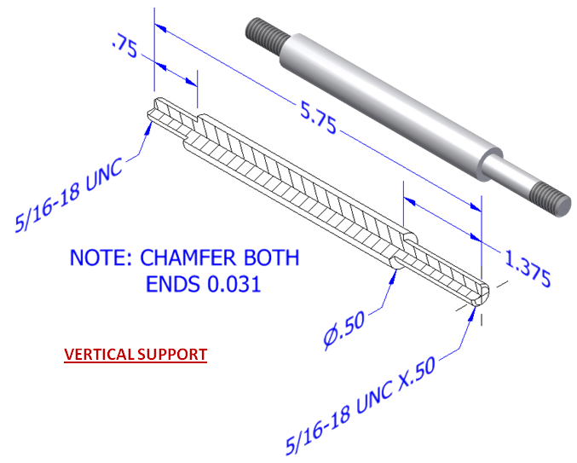
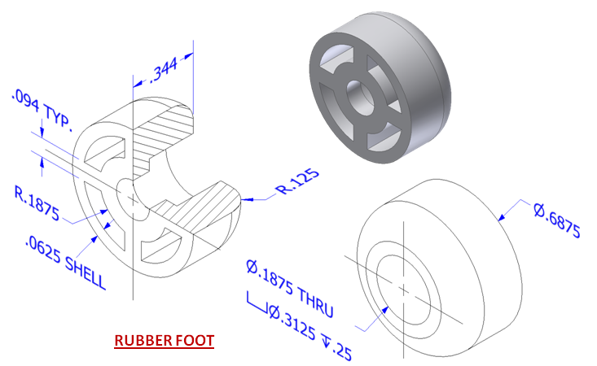

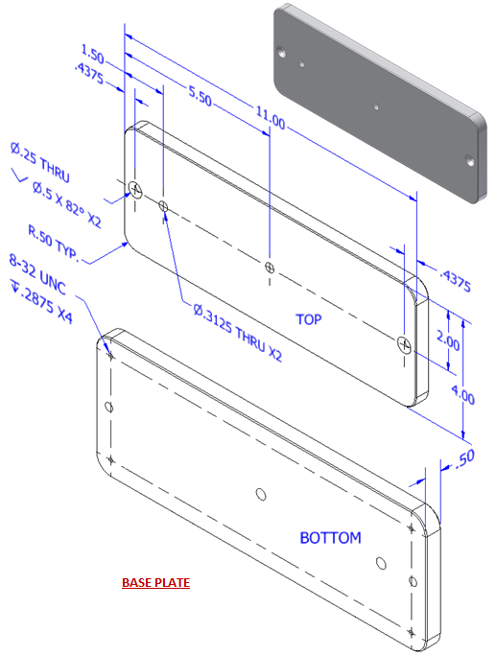

  - Model and assemble the following subassembly using the drawings provided.
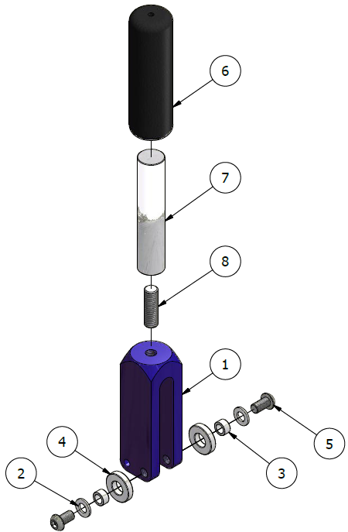
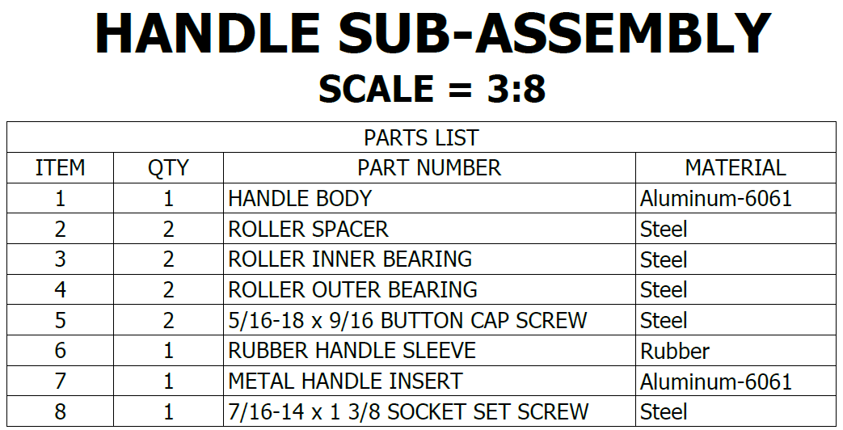
  - Model and assemble the following subassembly using the drawings provided.
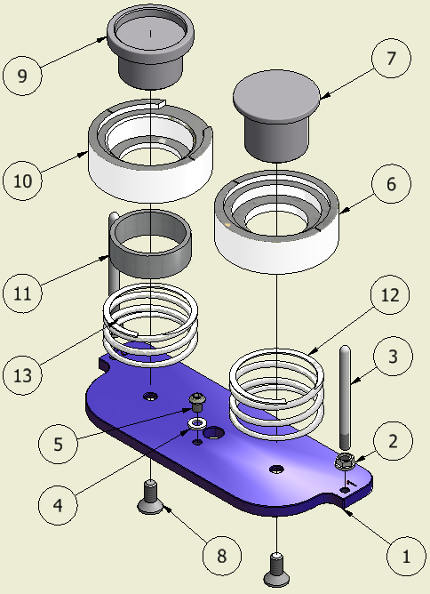
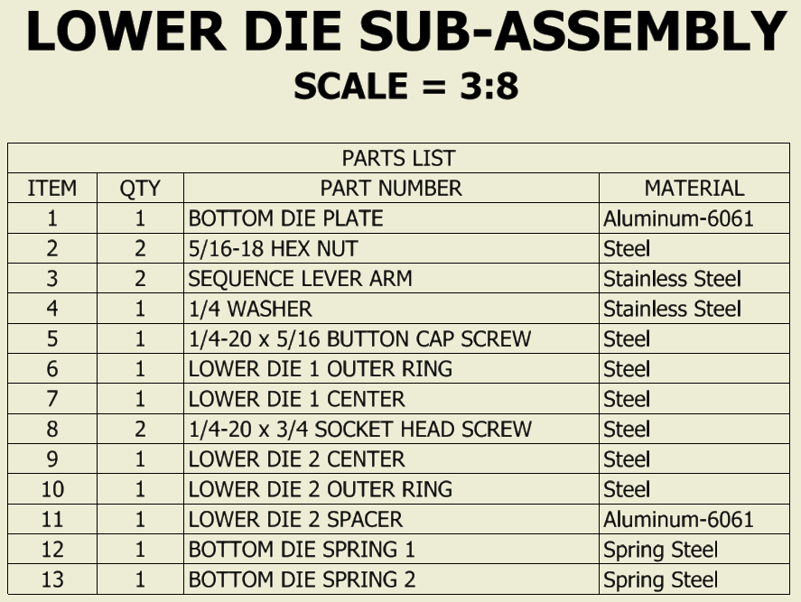

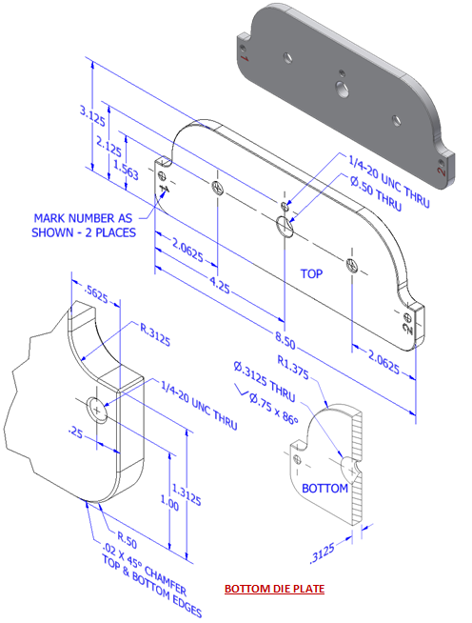

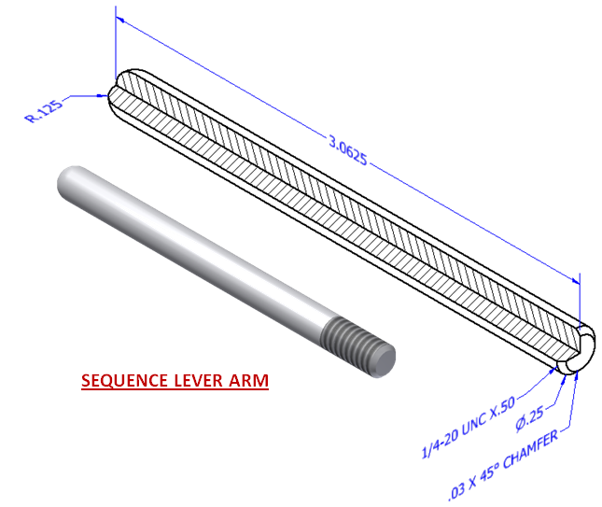
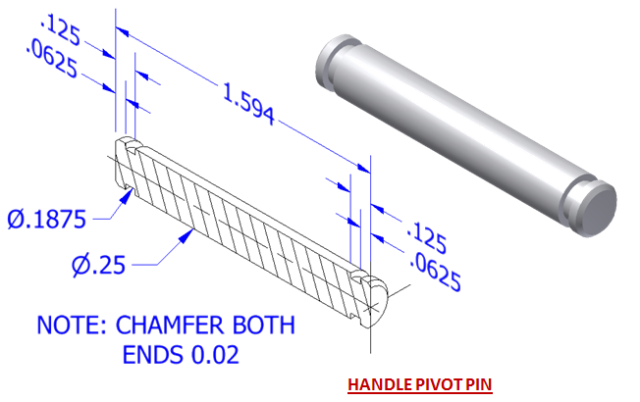

Conclusion
- What is an offset and how is it used?

- What is the difference between a mate and flush constraint?

- What is a subassembly?

- What advantages does CAD have over technical sketching?

- What three types of constraints can be applied to CAD sketches or models?

