Activity 8.4 Working Drawings (Button Maker)

Procedure
- Using previously modeled parts and sub-assemblies, create a complete assembly of the Button Maker using 3D solid modeling software. Use assembly constraints to constraint the Button Maker components and sub-assemblies. Use the parts list below to check off the components as you add them to the assembly

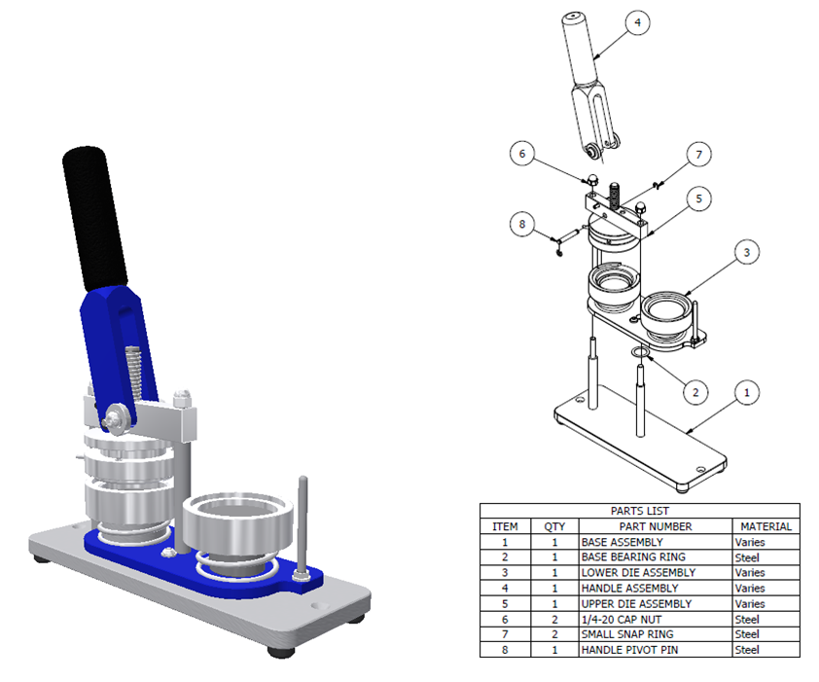

- Perform interference analyses on the components to determine if unnecessary overlaps occur. Save the assembly file when complete.
- Create part drawings for 10 components of the button maker that you modeled in Activity 8.1 Model a Button Maker. This might include (but is not limited to) part drawings of the following parts.
  - Base Plate
  - Rubber Foot
  - Vertical Support
  - Rubber Handle Sleeve
  - Bottom Die Plate
  - Handle Body
  - Upper Die Pressure Ring
  - Upper Die Center

For some components, you may need to create section or auxiliary views in order to fully detail the part. These additional views must be included on the corresponding part drawing. Note that unmodified off-the-shelf components (e.g., nuts, screws, washers) do not require dimensioned drawings. However, if an off-the-shelf component is modified, a technical drawing showing only the dimensions required to perform the modification is required.
- Provide an exploded view of your assembly with balloons and a parts list on a drawing sheet.
- Exchange your CAD drawings with a classmate. Assist your classmate by checking the drawings for errors. Identify errors using a red pencil.
- Revise your drawings, as necessary, based on your classmate’s review comments.

