Name:_______________________

Activity 2.2 Perspective Sketching
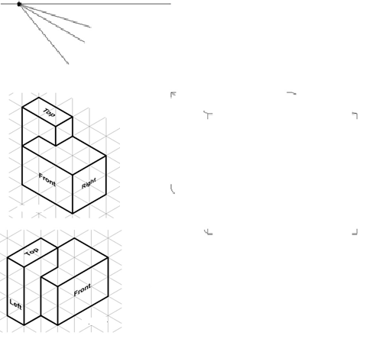
- Study the object represented in the isometric views below. Use the vanishing point and horizon line indicated to lay out light construction lines and create a one-point perspective sketch of the object within the given box. The perspective sketch must show the object in a top, left side, front view orientation. Delineate the visible edges of the sketch with heavy object lines.
DO NOT ERASE YOUR CONSTRUCTION LINES. Add tonal shading to the sketch when finished.

- Use the horizon line and vanishing points shown to lay out a two-point perspective sketch of the object shown in number 1 above using construction lines within the given box. The perspective sketch must show the object in a top, front, right side view orientation. Delineate the visible edges of the sketch with heavy object lines. DO NOT ERASE YOUR CONSTRUCTION LINES. Add tonal shading to the sketch.
- Create a one-point perspective sketch of a puzzle cube piece in your engineering notebook (as directed by your instructor) using pencil to create construction lines. Use ink to delineate the object lines and add tonal shading.
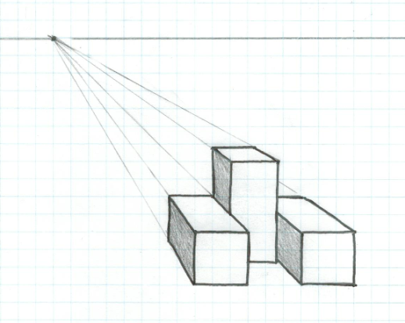

- Create a two-point perspective sketch of the same puzzle cube piece (used in number 3 above) in your engineering notebook (as directed by your instructor) using pencil to create construction lines. Use ink to delineate the object lines and add tonal shading.
- Select one of the following objects and create a one-point or two-point perspective sketch on grid paper or in your engineering notebook (as directed by your instructor). Shade the sketch.
- Highlighter, marker, etc.  - Clothes pin  - Flash drive  - Flashlight  - Coffee cup  - Toothbrush  - Monitor  - Surge protector | - Cell phone, ipod, ipad, Kindle, or similar  - Printer Remote control device  - Other object approved by your instructor | 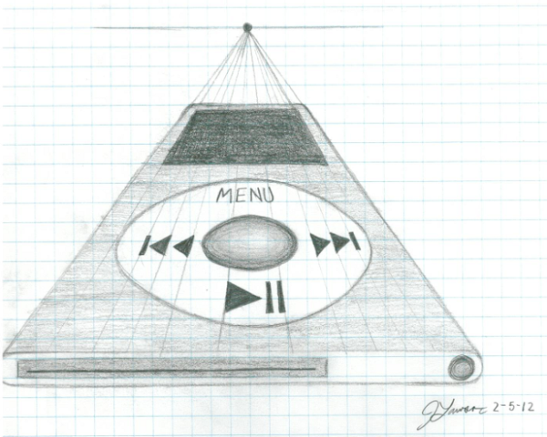

Conclusion
- What is a vanishing point?

- Aside from the number of vanishing points, what is the difference between a one-point, two-point, and three-point perspective sketch?

- How does a perspective drawing differ from an isometric drawing of the same object? When would you use a perspective view in lieu of an isometric drawing?

