Activity 2.3 Glass Box

Warm-Up
A box net is a flat pattern that will fold into a box. Study the following patterns. Some of the following patterns are cube nets, that is, if cut along the exterior lines and folded on the interior lines, the flat pattern can be transformed into a box in the form of a cube. Circle the flat patterns that are cube nets.
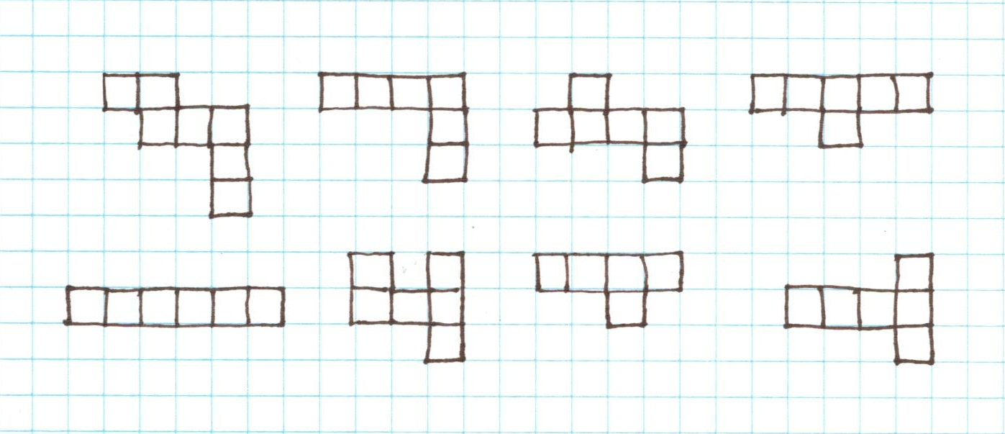

- Brainstorm additional cube nets. Sketch as many additional cube nets as you can think of in the space below. Avoid nets that are rotations or reflections of those already identified. You may use the attached grid paper to test your nets.

- Can you see a pattern to the nets that will fold into a box?
  - How many squares are included in a cube net? Why is this always the case?

  - What else is true about the arrangement of the squares in a cube net?

  - Put an X through sketches that are not unique, that is, that are rotations or reflections of the nets you identified in number 1 or sketched previously in number 2.

  - There should be at least six unique cube nets. Sketch any cube nets missing in the step above.

You will use one of your cube nets to build a glass box from transparency film. You will then place an object inside your glass box and sketch all six orthographic projections of the object on the box.

Remember that the orthogonal projections of a multi-view are carefully oriented with respect to the point of view shown by each. The principle multi-view used in the United States (called third-angle projection) provides orthogonal projections arranged and aligned as shown below.

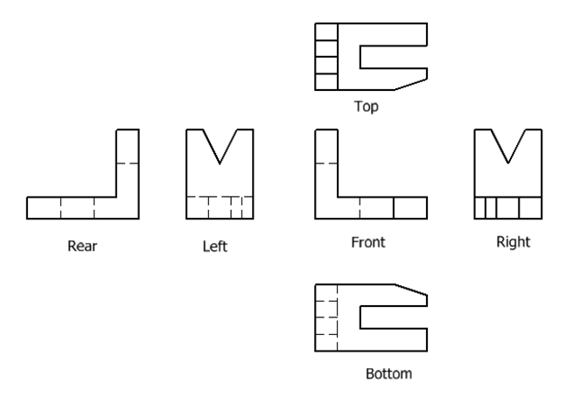

- Review your cube nets and compare them to the multiview of orthogonal projections above. Choose the cube net that will provide proper orientation of views when you unfold your glass box. Circle your chosen net above.
- Obtain approval of your net from your instructor and obtain a copy of your chosen net printed on transparency film. Instructor Initials ____
- Assemble your glass box. Use transparent tape to secure adjacent sides together except do not secure the top side at this time. You will need to open the box to place objects inside.
- Obtain a puzzle cube piece from your instructor. Carefully choose the best front view for the piece. Then tape a puzzle piece to the bottom of the transparent box so that your chosen front view is oriented toward the Front face of the glass box. Be sure to carefully align the puzzle piece to the grid lines. Then secure the top side of the box with transparent tape.

- Sketch orthogonal projections on each face of the box until all six views are drawn on the box faces. Be sure to include hidden lines to represent hidden edges.
- Remove the tape and flatten the transparency film.
- Using your flattened transparent net, reproduce the six views on grid paper in the correct orientation. Include construction lines to demonstrate proper alignment between adjacent views and hidden lines where appropriate. Correctly label each view.
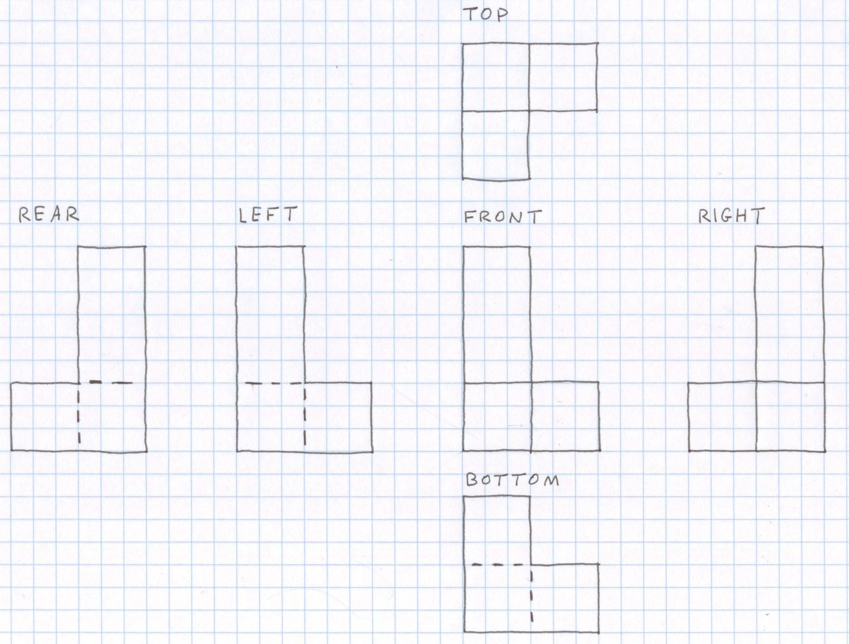

- Exchange your puzzle piece with another student. Carefully choose the front view for the new piece. Then, using your glass box if necessary, sketch a three-view (to include a front, top and right view) and the related isometric pictorial. Be sure to align your views correctly. Include hidden lines where applicable.
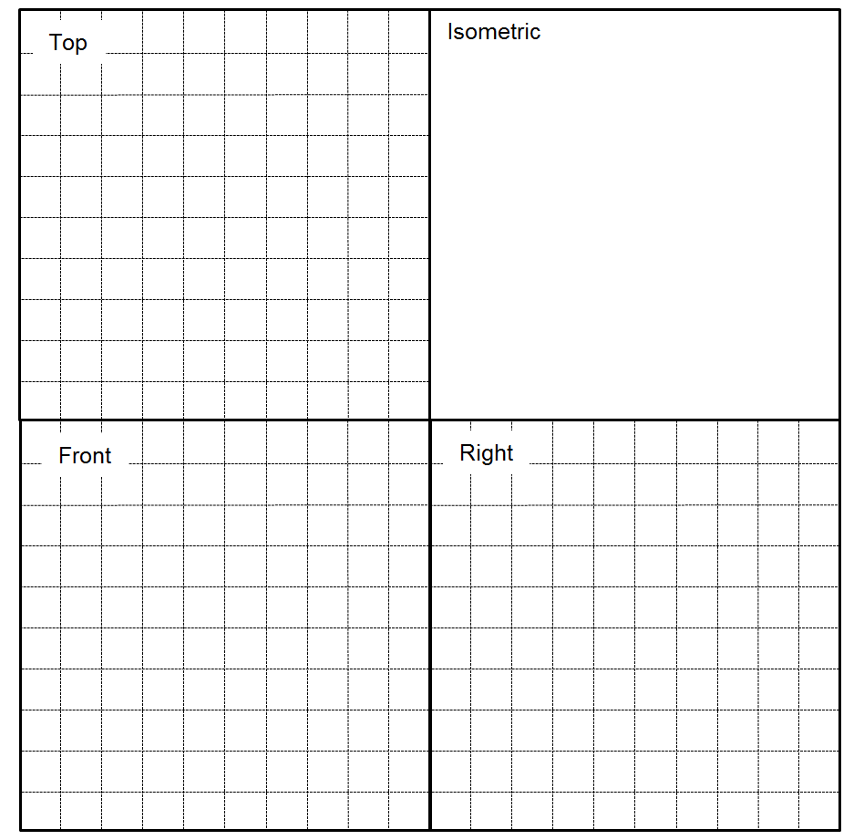

Study the images below. Imagine the object inside your glass box. Use points, construction lines, hidden lines, center lines, and object lines where applicable to sketch the missing view. Then add hidden lines and center lines to the other views, as applicable.

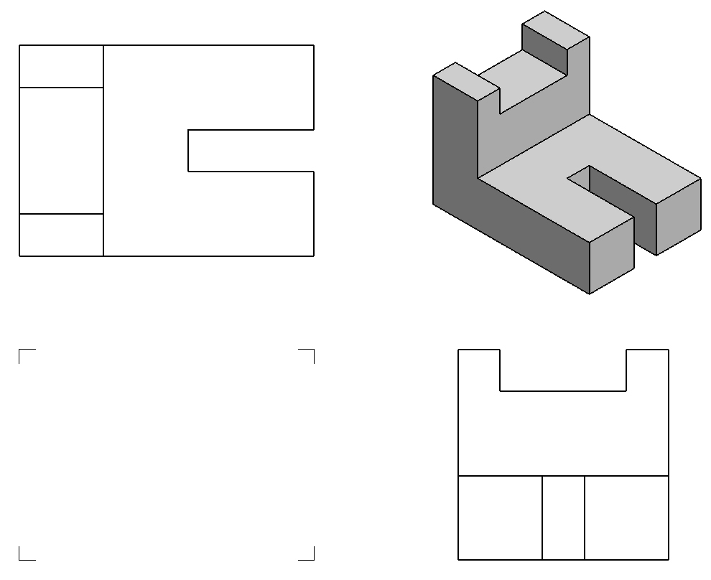
- Draw the missing view.

- Draw the missing view.
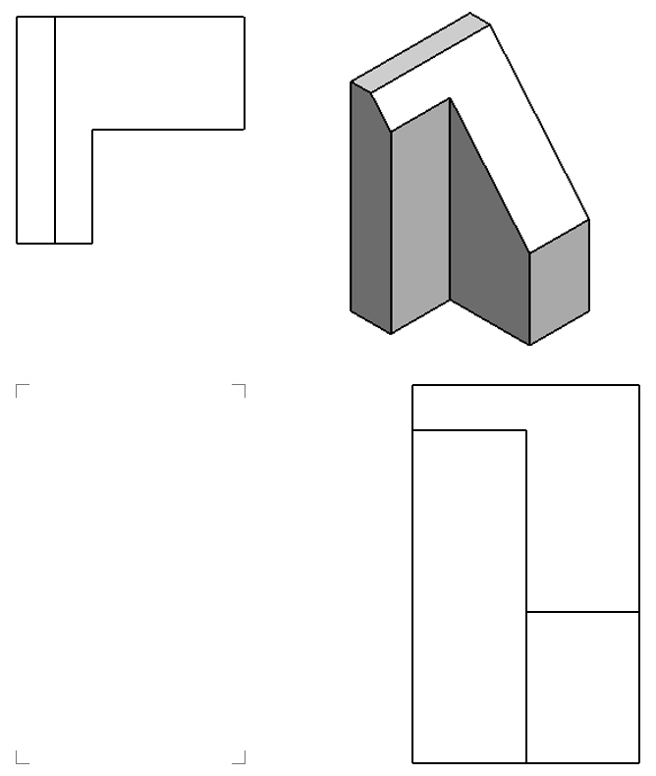

- Draw the missing view.
- Draw the missing view.
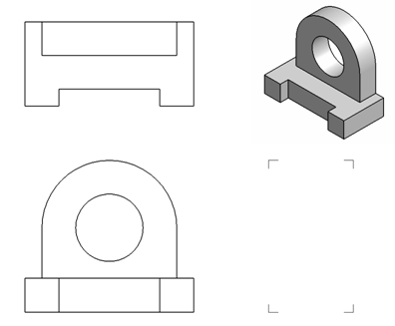

- Draw the missing view.
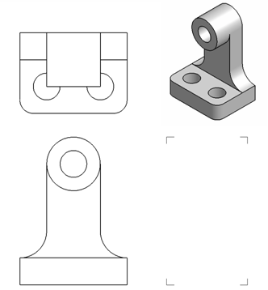

Conclusion

- How do you determine the orientation of orthogonal projections in a multi-view drawing?

- How would you describe the geometric relationship that exists between the adjacent views of a multi-view drawing?

- Why is it important to lay out a multi-view sketch with points and construction lines before drawing object lines?

