Activity 2.4 Multi-view Sketching

- Study the images below. The various surfaces of the object are identified by letters on the isometric drawing and by numbers on the multi-view drawing. In the table, write the number that corresponds with the lettered surface in each of the top, front, and right side views.

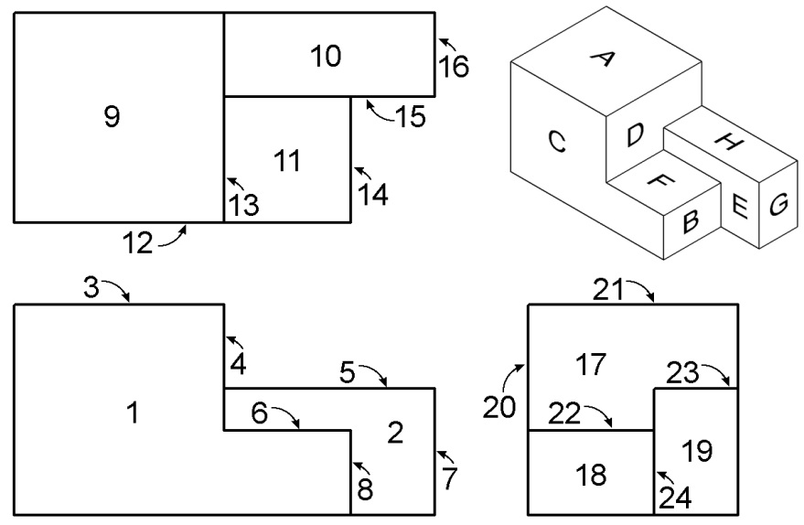 |  | Top | Front | Side
 | A | 9 | 3 | 21
 | B
 | C
 | D
 | E
 | F
 | G
 | H

- For each of the objects below, select the face that would provide the best front view. Then create a quick sketch of the orthographic projection showing your selected view in approximate proportions. Finally, determine the minimum number of views required to adequately represent the object and indicate the views (in addition to the front view) that you would use to represent the object.
Object | Front View Sketch
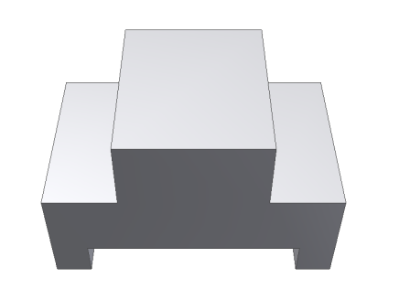
Minimum Number of views: | Additional Orthographic Views to include:

Object | Front View Sketch
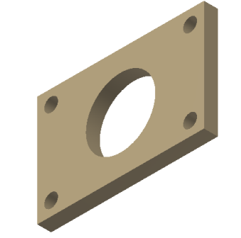
Minimum Number of views: | Additional Orthographic Views to include:
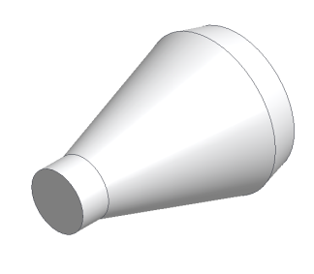
Minimum Number of views: | Additional Orthographic Views to include:
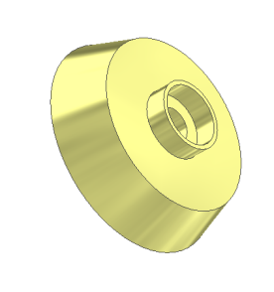
Minimum Number of views: | Additional Orthographic Views to include:

Object | Front View Sketch
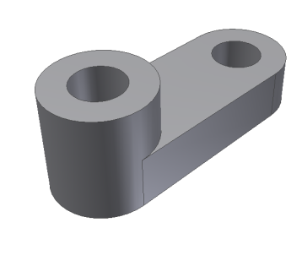
Minimum Number of views: | Additional Orthographic Views to include:
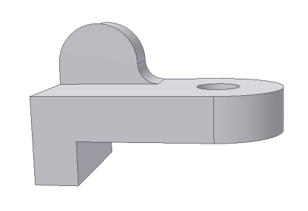
Minimum Number of views: | Additional Orthographic Views to include:

Study the isometric views in the next four pages. Use points, hidden lines, construction lines, and object lines to sketch the three common views used to explain the object. The scale is 1:1, which means that each grid line on the isometric view represents a grid line on the orthographic grid. DO NOT ERASE YOUR POINTS AND CONSTRUCTION LINES.

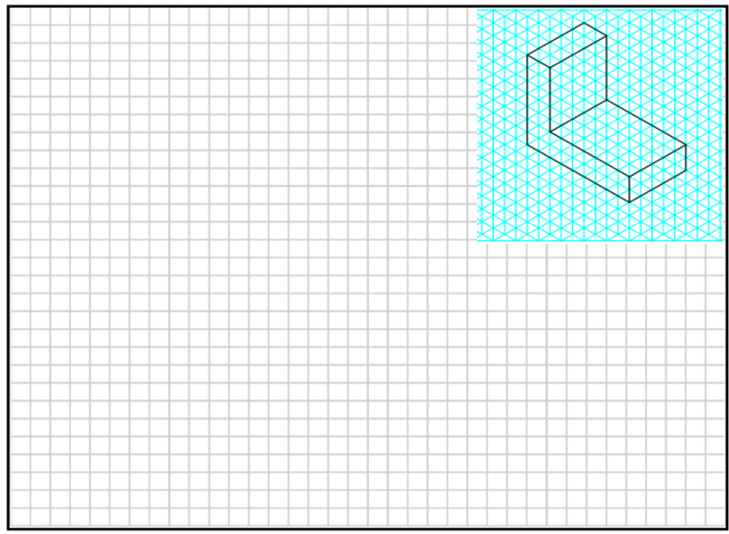

4.
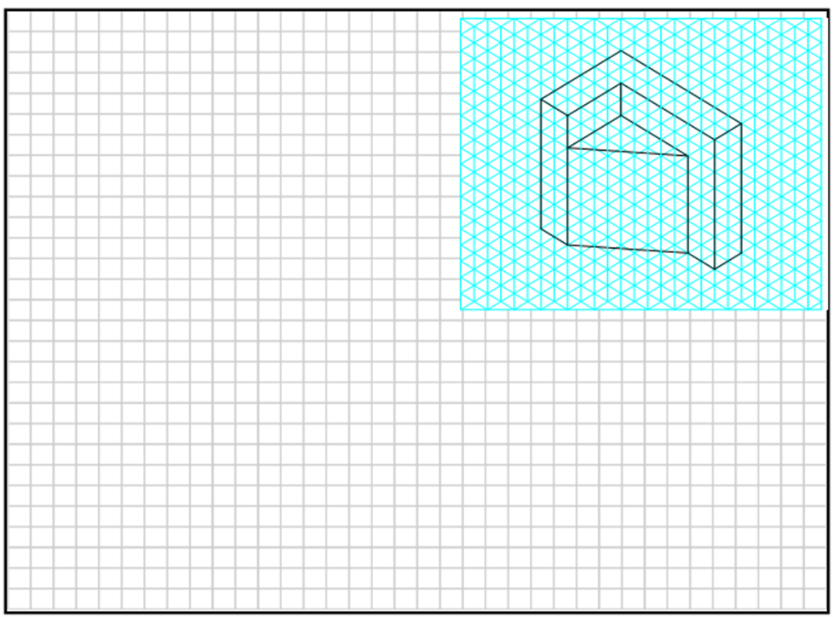

5.
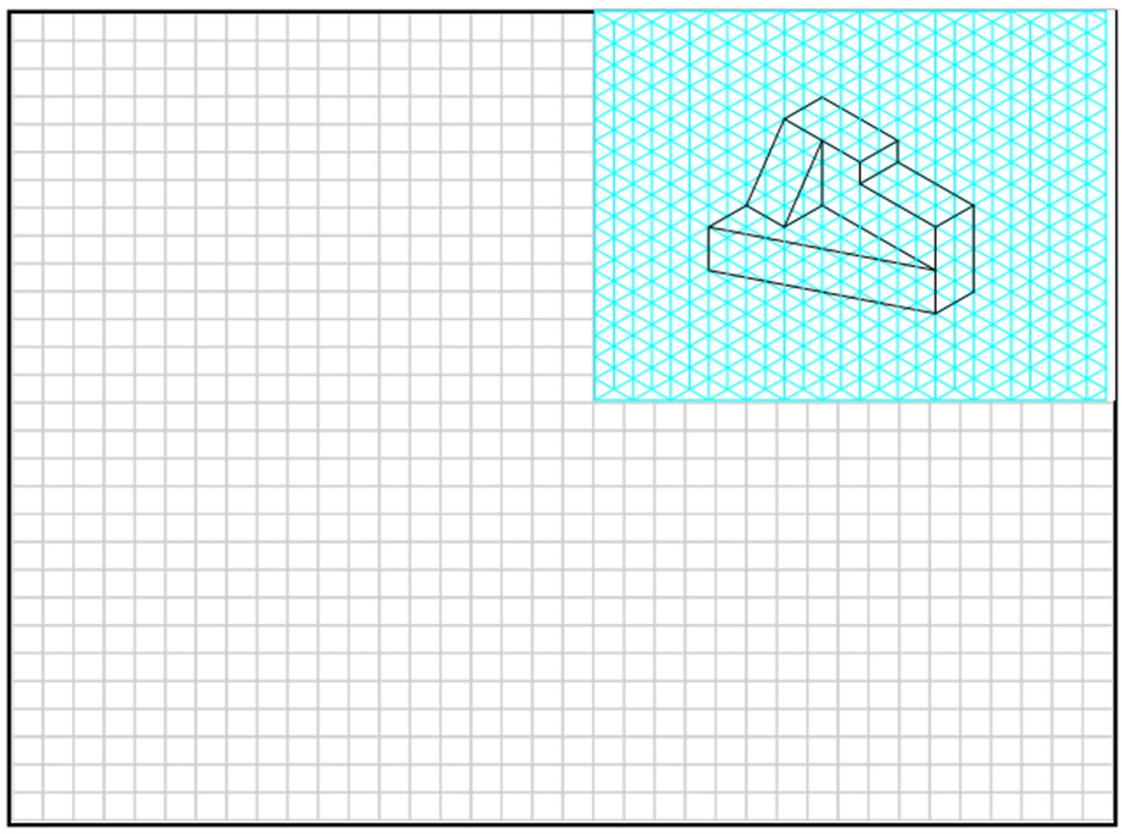

Extending Your Learning
For each of the following, create properly aligned orthographic projections on grid paper. Use the minimum number of orthographic projections necessary to fully describe the object shown. Include object lines, hidden lines, and center lines in all views, as appropriate. The sketches should be approximately proportional, but are not required to be drawn to scale.

6.  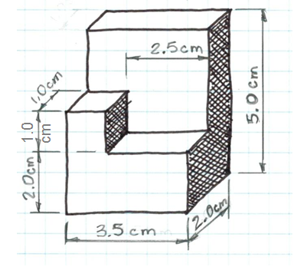 | 7.  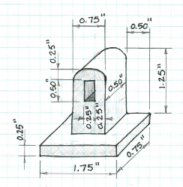 | 8.  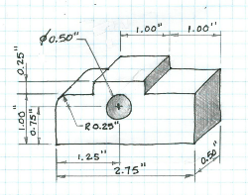

Conclusion
- What is the purpose of construction lines? Object lines?

- What is the purpose of hidden lines and center lines?

- What type of pictorial is shown in the first representation in number 2? How can you tell?

- What type of pictorial view is shown in number 6? How can you tell?

- Why would building professionals, such as machinists and contractors, prefer multi-view drawings over pictorial drawings?

