Activity 2.5 Sketching Practice

Introduction
Sketching is a valuable engineering skill that needs to be developed through practice. Through practice you will be able to communicate your vision of your idea.

In this activity you will apply the skills that you learned earlier in this lesson to more complex objects.

- Create a one-point perspective of the object represented by the orthographic projections. Apply tonal shading.
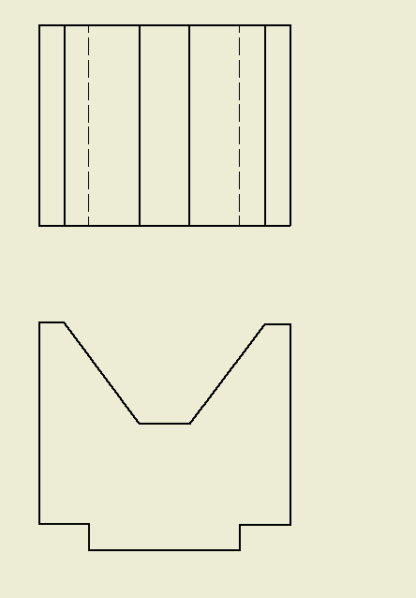

- Create an isometric view of the object represented by the multi-view. Apply tonal shading.

- Sketch a two-point perspective view of the object represented by the sketch. Apply tonal shading.
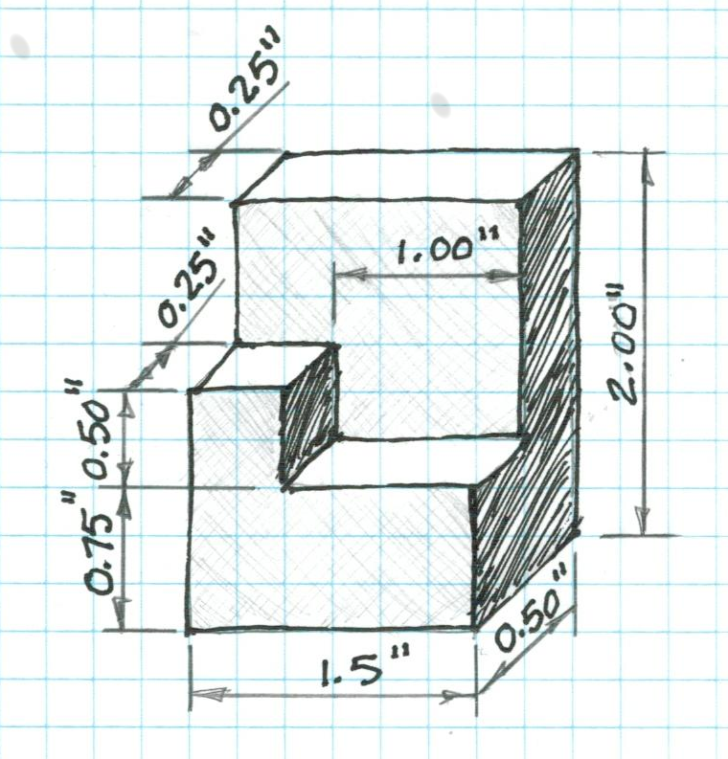

- The flat pattern below will be used to create a hollow puzzle cube piece from a sheet of plastic. Each square on the pattern is 1 in. x 1 in. Sketch an isometric view of the puzzle piece to scale on grid paper. Be sure to select the best front view and orient the sketch appropriately.
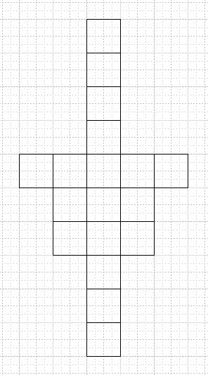
1 ″
1 ″

Sketch the orthogonal projection of this isometric view.
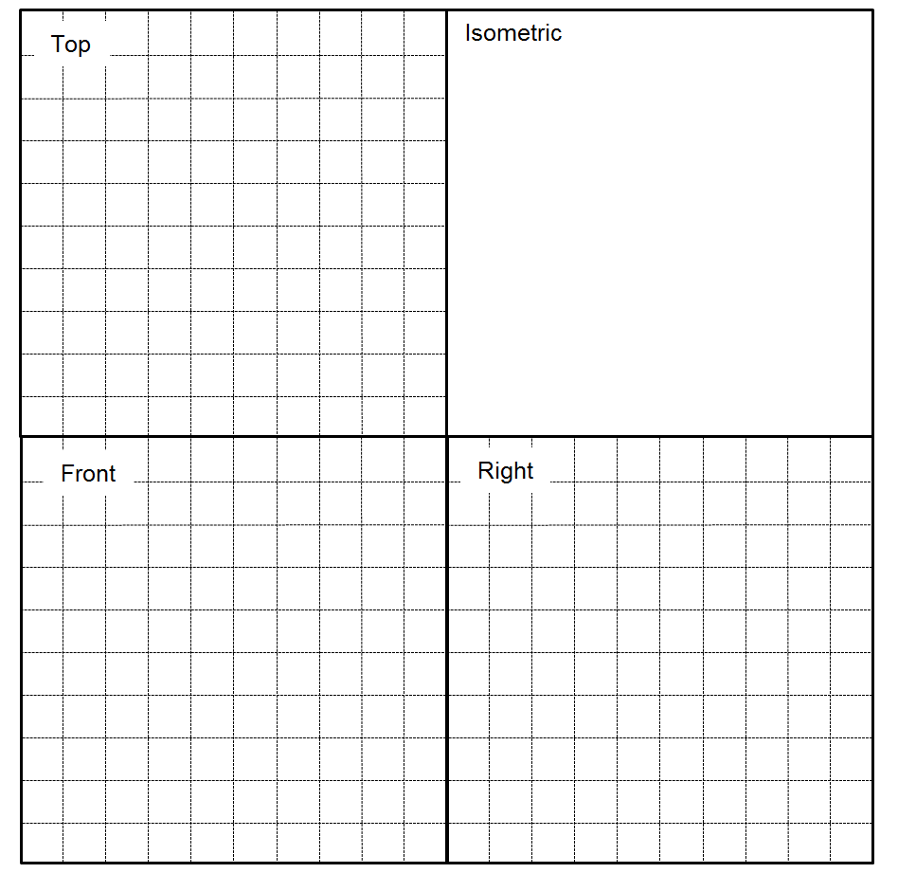

Conclusion

- What is a technical sketch? What is an artistic sketch? How are the two similar and how are they different?

- How do you envision applying your sketching skills in other classes?

- How would you teach sketching to a student next year?

