Activity 3.9 Statistics and Quality
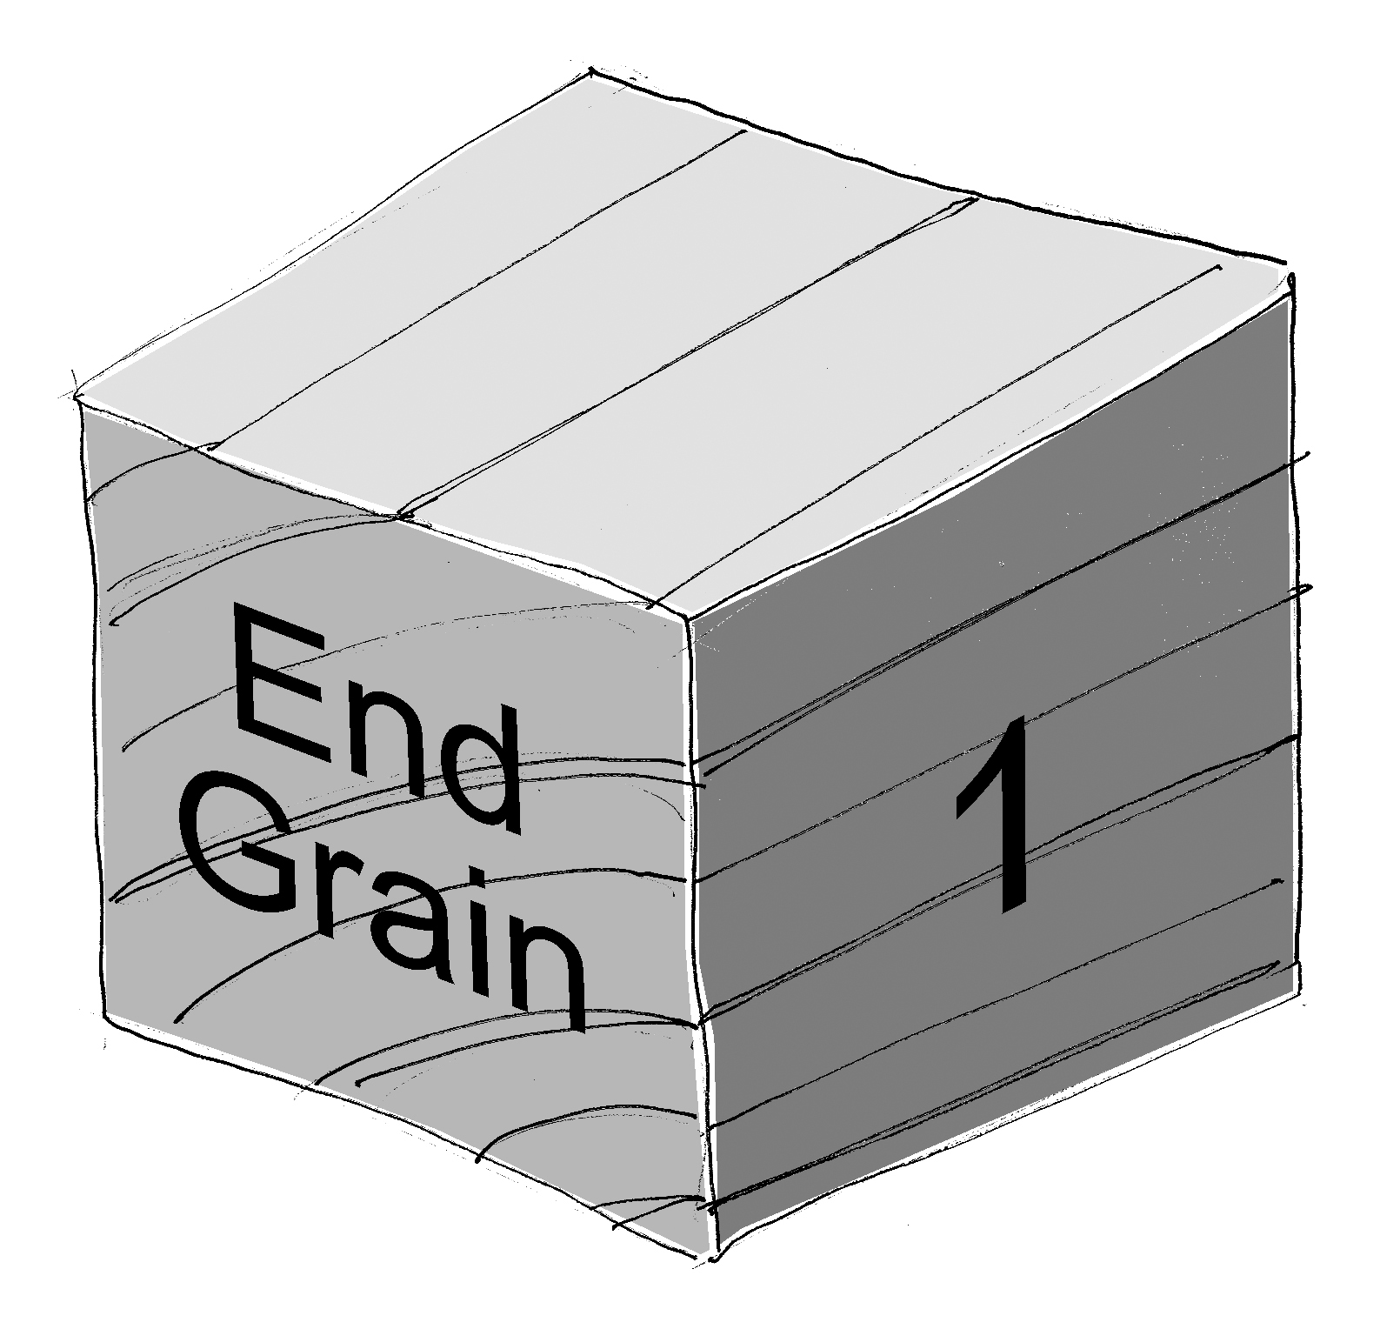
Equipment
- Engineering notebook
- Pencil
- Dial caliper

Procedure
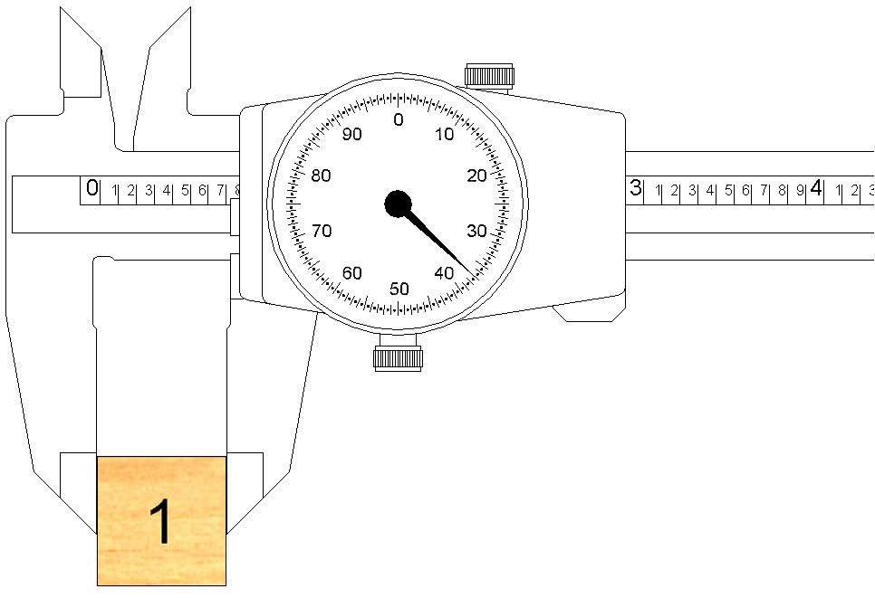
Obtain a set of 27 wooden cubes (3/4 in.) from your instructor. Label each cube (1 through 27) lightly in pencil. Measure the side length of each block along the grain. When taking a measurement, position the block so the caliper measuring surfaces are touching the end grain faces. Record the measurements to create a data set. For this analysis a precision of .001 is necessary; therefore, record each measurement to the nearest one thousandth of an inch (.001 in).

Wood cube 1: |  |  | Wood cube 15:
Wood cube 2: |  |  | Wood cube 16:
Wood cube 3: |  |  | Wood cube 17:
Wood cube 4: |  |  | Wood cube 18:
Wood cube 5: |  |  | Wood cube 19:
Wood cube 6: |  |  | Wood cube 20:
Wood cube 7: |  |  | Wood cube 21:
Wood cube 8: |  |  | Wood cube 22:
Wood cube 9: |  |  | Wood cube 23:
Wood cube 10: |  |  | Wood cube 24:
Wood cube 11: |  |  | Wood cube 25:
Wood cube 12: |  |  | Wood cube 26:
Wood cube 13: |  |  | Wood cube 27:
Wood cube 14:

- Use a calculator or an excel spreadsheet to perform a statistical analysis of the data to determine each of the following.
Mean:________________ Median: ________________
Mode: ________________ Range: ________________
Sample Standard Deviation: ________________
- Create a histogram by hand or on excel to represent the data. Use seven to ten class intervals (bin values). Be sure to label your axes and define units where appropriate.
- Does your data appear to be normally distributed? Justify your answer.
- Based on past experience, 95% of the wooden blocks received from the manufacturer are within acceptable dimensional limits. However, five percent of the blocks are either too big or too small. When these “out of tolerance” pieces are used to construct a puzzle prototype, the puzzle pieces do not fit well together, and in some cases, the puzzle cannot be solved because of the incorrectly sized wooden cubes.
To minimize the probability that an ill-sized wooden cube will result in a poor prototype, you will determine a range of acceptable side lengths and dispose of any wooden cubes that do not meet your size criteria.
- Assuming a normal distribution, determine a criterion of side length values such that approximately 95% of the wooden cubes supplied by the manufacturer will meet your criteria. Show your work.
  - Express your answer using plus/minus notation.
  - Express your answer using a compound inequality.
- Without looking at your data, predict the number of your wooden cubes (out of 27) that you would predict will meet the criteria. Justify your answer.
- How many of your 27 wooden cubes actually meet the side length criteria?
- In most cases, the answers to b and c above will differ. Why?
Conclusion
- You have calculated statistics related to your 27 wooden cubes. Consider how your statistical analysis results would change if all of the data values for all of the cubes measured by all of the students in your class were compiled and used for analysis. Then answer the following questions.
  - How would the histogram of the entire class’ data change compared to your histogram?
  - What value would you expect for the mean of the length measurements if the data from the entire class were used? Explain.
  - Would you expect the standard deviation of the class’ measurements be larger, smaller, or about the same as the standard deviation of your measurements? Why?
- In which phase(s) of a design process might statistics be most useful? Why?
- How can statistics of a product’s dimensions be used to assess the quality of the product?

