CMIC 1 Unit 8 Review Name____________________ Date_______ Period____
- Alex and Emma play a game that uses two six-sided dice with the numbers 1, 1, 2, 3, 4, and 5 on the sides.
  - Make a chart that shows the sample b. Make a table for the probability distribution
space of all possible sums when you of the sum of these two dice.
roll two of these dice.
c. What sum will you most likely get?_______ d. What is the probability of getting a sum less than 5?________
e. What is the probability of rolling a sum of 4 or having a 3 showing on at least one of the dice?

- Assume you roll 2 four-sided dice with the numbers 1, 2, 3, 4 on the faces. You’ve made up a game with friends that rolling a sum of 4 wins the game.

  - How could you use the calculator to simulate rolling the two dice?

  - Simulate 10 trials of how long it takes to win the game.

  - Calculate the mean of YOUR frequency table.

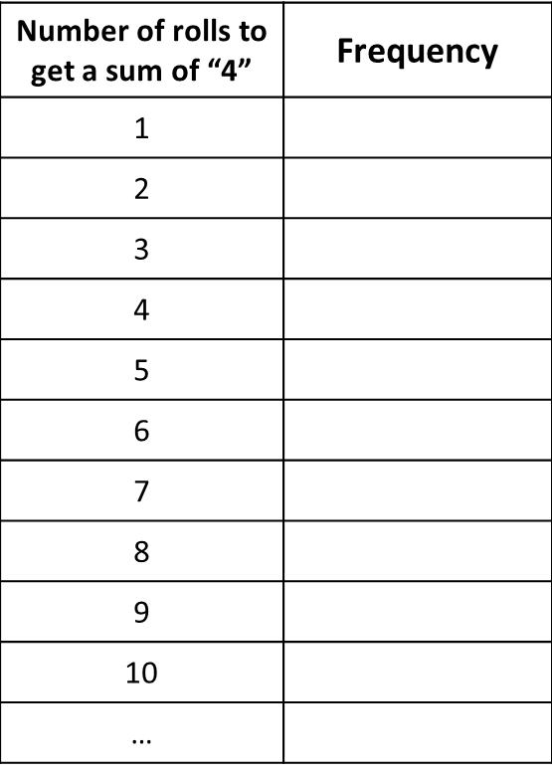

- 25 kids were surveyed and asked which toy they wanted for Christmas, as shown in the table.
  - Why does the right column add to more than 25?
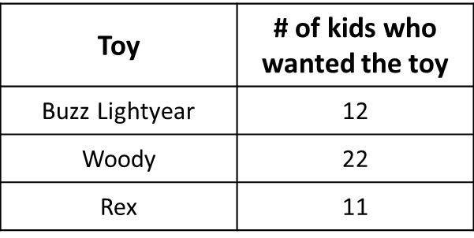

  - What is the probability that a kid will want a Woody toy?

  - 92% of kids will want a Buzz or Rex toy. Do you agree or disagree?

