Unit 7 Dimensioning Review

Download the object shown below (Arbor Press Base) from the website and save in your Unit 7 folder. Then create a fully dimensioned multi-view drawing (on size A paper) to document the part, save the CAD files as Arbor Press Base Practice in your unit 7 folder. Print and have a peer grade your drawing. Make sure you watch out for the following mistakes:
  - Extension Lines crossing Dimension Lines
  - Double Dimensioning
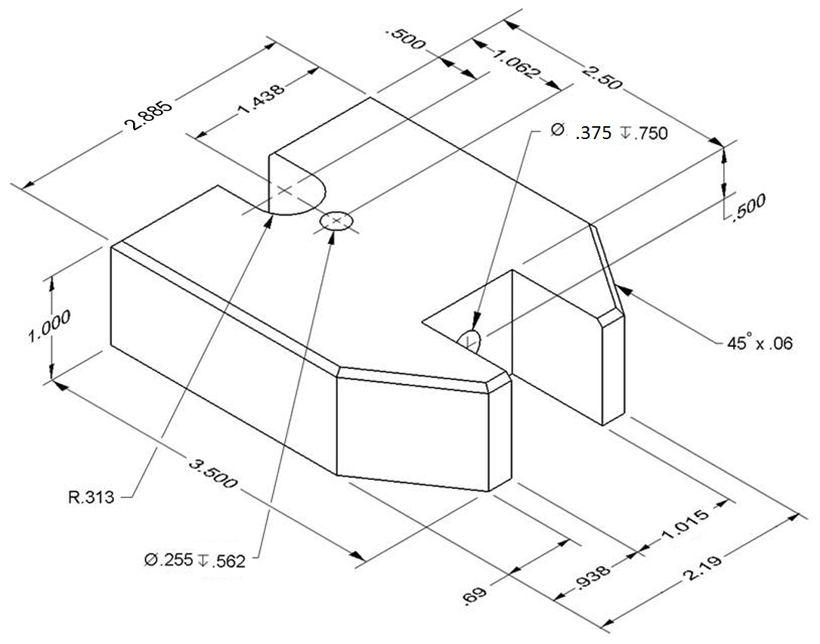

Once your peer is done grading your work, make any necessary changes and print. Have another peer review your work. Keep this going until there are no more changes to be made in your documentation.

