CMIC 2 – Unit 3 Name: _____________________________
Discovering Circles

- Using the applet on the mini unit website, complete the following steps and questions.
- Place the center of the circle on (0, 0). Put the red dot on the circle on point (-1, 0).
- What is the radius of this circle?

- Look at the equation above the graph. Write the equation as you see it.

- Now, put the center of the circle on (2, 1). Put the other red doe on (0, 1).
- What is the radius of this circle?

- Look at the equation above the graph. Write the equation as you see it.

- Now, put the center of the circle on (-1, 3). Put the other red dot on (-4, 3).
- What is the radius of this circle?

- Look at the equation above the graph. Write the equation as you see it.

- As the radius of your circle changes, what about the equation changes?

- As the coordinates of your circle change, how does the equation change?

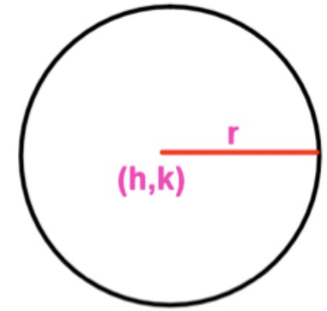
- Given the following general circle, fill in the blanks of the provided
‘Standard Form’ of the equation of a circle.
$${(x-____)}^{2}+{(y-_____)}^{2}=__{__}^{2}$$

