|  |
| --- |
| **Engineering Formula Sheet** |



1.0 Statistics

***Mode***

Place data in ascending order.

Mode = most frequently occurring value**(1.4)**

If two values occur with maximum frequency the data set is *bimodal.*

If three or more values occur with maximum frequency the data set is *multi-modal.*

***Mean***

$\text{μ} \text{=} \frac{\sum{{\text{x}}_{\text{i}}}}{\text{N}}$**(1.1a) $\overline{\text{x}}\text{ = }\frac{\sum{{\text{x}}_{\text{i}}}}{\text{n}}$**  **(1.1b)**

µ = population mean

$\overline{\text{x}}$ = sample mean

Σxi = sum of all data values (x1, x2, x3, …)

N = size of population

n = size of sample

***Standard Deviation***

$σ=\sqrt{\frac{\sum{{\left({\text{x}}_{\text{i}} \text{- μ}\right)}^{\text{2}}}}{\text{N}}}$ (Population) **(1.5a)**

$\text{s}=\sqrt{\frac{\sum{{\left({\text{x}}_{\text{i}} \text{- }\overline{\text{ x}}\right)}^{\text{2}}}}{\text{n ‒1}}}$ (Sample) **(1.5b)**

σ = population standard deviation

s = sample standard deviation

xi = individual data value ( x1, x2, x3, …)

= sample mean

N = size of population

n = size of sample

***Median***

Place data in ascending order.

If N is odd, median = central value **(1.2)**

If N is even, median = mean of two central values

N = size of population

***Range* (1.5)**

Range = xmax - xmin  **(1.3)**

xmax = maximum data value

xmin = minimum data value

2.0 Probability

***Independent Events***

P (A and B and C) = PAPBPC **(2.3)**

P (A and B and C) = probability of independent events A and B and C occurring in sequence

PA = probability of event A

***Frequency***

${\text{f}}_{\text{x}}\text{ = }\frac{{\text{n}}_{\text{x}}}{\text{n}}$**(2.1)**

**fx = relative frequency of outcome x**

nx = number of events with outcome x

n = total number of events



***Mutually Exclusive Events***

P (A or B) = PA + PB **(2.4)**

P (A or B) = probability of either mutually exclusive event A or B occurring in a trial

PA = probability of event A

***Binomial Probability***

***(order doesn’t matter)***

${\text{P}}_{\text{k}}\text{ = }\frac{\text{n!(}{\text{p}}^{\text{k}}\text{)(}{\text{q}}^{\text{n-k}}\text{)}}{\text{k!(n-k)!}}$**(2.2)**

Pk = binomial probability of k successes in n trials

p = probability of a success

q = 1 – p = probability of failure

k = number of successes

n = number of trials

***Conditional Probability***

$P\left(A | D\right)=\frac{P(A)∙P(D|A)}{P\left(A\right)∙P\left(D | A\right)+P(\sim A)∙P(D|\sim A)}$**(2.5)**

P (A|D) = probability of event A given event D

P(A) = probability of event A occurring

P(~A) = probability of event A not occurring

P(D|̶~A) = probability of event D given event A did not occur

EDD

BE

CIM

IED

POE

DE

CEA

AE

**1**

3.0 Plane Geometry

***Rectangle***

Perimeter = 2a + 2b **(3.9)**

Area = ab **(3.10)**

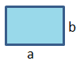

***Ellipse***

$\text{Area} \text{=} \text{π} \text{a b}$**(3.8)**

2b

2a

***Circle***

$\text{Circumference} \text{=}\text{2 }\text{π} \text{r}$**(3.1)**

$\text{Area = }\text{π} {\text{r}}^{\text{2}}$**(3.2)**

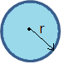

***Triangle* (3.6)**

Area = ½ bh **(3.11)**

a2 = b2 + c2 – 2bc·*cos∠*A **(3.12)**

b2 = a2 + c2 – 2ac·*cos∠*B **(3.13)**

c2 = a2 + b2 – 2ab·*cos∠*C **(3.14)**

h

b

a

c

A

B

C

***Parallelogram***

Area = bh **(3.3)**

h

b

***Regular Polygons***

$\text{Area = n}\frac{\text{s(}\frac{1}{2}\text{ f)}}{\text{2}}$**(3.15)**

n = number of sides

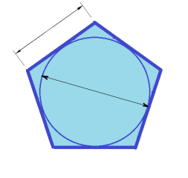

f

s

***Right Triangle***

c2 = a2 + b2 **(3.4)**

**(3.5)**

**(3.6)**

$\text{tan}{\text{θ}}\text{ = }\frac{\text{a}}{\text{b}}$**(3.7)**

b

c

θ

a

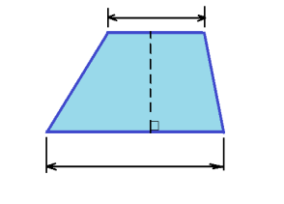

***Trapezoid***

Area = ½(a + b)h **(3.16)**

ah

hh

bh

4.0 Solid Geometry

***Cube***

Volume = s3 **(4.1)**

Surface Area = 6s2 **(4.2)**

s

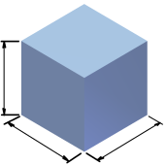

s

s

***Sphere***

Volume = π r**3 (4.8)**

Surface Area = 4 π r2 **(4.9)**

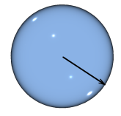

r

***Rectangular Prism***

Volume = wdh **(4.3)**

Surface Area = 2(wd + wh + dh) **(4.4)**

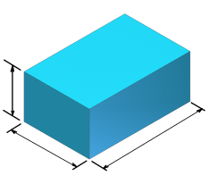

h

d

w

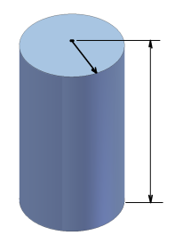

h

r

***Cylinder***

Volume = π r2 h **(4.10)**

Surface Area = 2 π rh+2 π r2 **(4.11)**

EDD

BE

CIM

IED

POE

DE

CEA

AE

**2**

***Irregular Prism***

Volume = Ah (**4.12)**

A = area of base

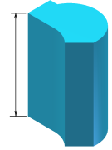

h

5.0 Constants

**g = 9.8 m/s2 = 32.27 ft/s2**

**G = 6.67 x 10-11 m3/kg·s2**

**π = 3.14159**

***Pyramid***

$\text{Volume =} \frac{\text{Ah}}{\text{3}}$**(4.7)**

A = area of base

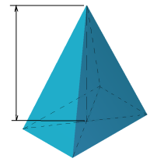

h

***Right Circular Cone***

$\text{Volume = }\frac{\text{π}{\text{r}}^{\text{2}}\text{h}}{\text{3}}$**(4.5)**

$\text{Surface Area} \text{=} \text{π} \text{r} \sqrt{{\text{r}}^{\text{2}}\text{+}{\text{h}}^{\text{2}}}$**(4.6)**

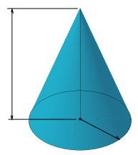

r

h

6.0 Conversions

***Mass/Weight* (6.1)**

1 kg = 2.205 lbm

1 slug = 32.2 lbm

1 ton = 2000 lb

1 lb = 16 oz

***Energy* (6.10)**

1 J = 0.239 cal

= 9.48 x 10-4 Btu

= 0.7376 ft·lbf

1kW h = 3,600,000 J

***Area* (6.4)**

1 acre = 4047 m2

= 43,560 ft2

= 0.00156 mi2

***Force* (6.7)**

1 N = 0.225 lb

1 kip = 1,000 lb

***Pressure* (6.8)**

1 atm = 1.01325 bar

= 33.9 ft H2O

= 29.92 in. Hg

= 760 mm Hg

= 101,325 Pa

= 14.7 psi

1psi = 2.31 ft of H2O

***Length (6.2)***

1 m = 3.28 ft

1 km = 0.621 mi

1 in. = 2.54 cm

1 mi = 5280 ft

1 yd = 3 ft

***Volume* (6.5)**

1L = 0.264 gal

= 0.0353 ft3

= 33.8 fl oz

1mL = 1 cm3 = 1 cc

7.0 Defined Units

1 J = 1 N·m

1 N = 1 kg·m / s2

1 Pa = 1 N / m2

1 V = 1 W / A

1 W = 1 J / s

1 W = 1 V / A

1 Hz = 1 s-1

1 F = 1 A·s / V

1 H = 1 V·s / V

***Temperature Unit Equivalents* (6.6)**

1 K = 1 ºC

= 1.8 ºF

= 1.8 ºR

See below for temperature calculation

***Power* (6.9)**

1 W = 3.412 Btu/h

= 0.00134 hp

= 14.34 cal/min

= 0.7376 ft·lbf/s

1 hp = 550 ft∙lb/sec

***Time (6.3)***

1 d = 24 h

1 h = 60 min

1 min = 60 s

1 yr = 365 d

|  |  |  |  |  |  |  |
| --- | --- | --- | --- | --- | --- | --- |
| **Numbers Less Than One** | | |  | **Numbers Greater Than One** | | |
| Power of 10 | Prefix | Abbreviation |  | Power of 10 | Prefix | Abbreviation |
| 10-1 | deci- | d |  | 101 | deca- | da |
| 10-2 | centi- | c |  | 102 | hecto- | h |
| 10-3 | milli- | m |  | 103 | kilo- | k |
| 10-6 | micro- | **µ** |  | 106 | Mega- | M |
| 10-9 | nano- | n |  | 109 | Giga- | G |
| 10-12 | pico- | p |  | 1012 | Tera- | T |
| 10-15 | femto- | f |  | 1015 | Peta- | P |
| 10-18 | atto- | a |  | 1018 | Exa- | E |
| 10-21 | zepto- | z |  | 1021 | Zetta- | Z |
| 10-24 | yocto- | y |  | 1024 | Yotta- | Y |

8.0 SI Prefixes

***Force and Moment***

F = ma **(9.7a)** M = Fd⊥ (**9.7b)**

F = force

m = mass

a = acceleration

M = moment

d⊥= perpendicular distance

9.0 Equations

***Temperature***

TK = TC + 273 **(9.4)**

TR = TF + 460 **(9.5)**

TF = Tc + 32 **(9.6)**

TK = temperature in Kelvin

TC = temperature in Celsius

TR = temperature in Rankin

TF = temperature in Fahrenheit

***Mass and Weight***

m = VDm **(9.1)**

W = mg **(9.2)**

W = VDw **(9.3)**

V = volume

Dm = mass density

m = mass

Dw = weight density

W = weight

g = acceleration due to gravity

***Equations of Static Equilibrium***

ΣFx = 0 ΣFy = 0 ΣMP = 0 **(9.8)**

Fx = force in the x-direction

Fy = force in the y-direction

MP = moment about point P

**3**

CEA **6**

AE **5**