CMIC 2 – Unit 3 Name: _________________________
Identifying Triangles
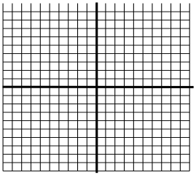
- Using coordinate geometry, classify $∆ABC$ as scalene, isosceles, or equilateral given the vertices located at $ABC= \left[\begin{matrix}-2 & 2 & 0 \\ -2 & -2 & 5\end{matrix}\right]$.

- Find the perimeter of $∆PQR$ with vertices located at$PQR= \left[\begin{matrix}-4 & -1 & 6 \\ -2 & -6 & -3\end{matrix}\right]$.

- Is $∆UGA$, formed by the points $UGA= \left[\begin{matrix}-3 & 1 & 5 \\ -3 & 7 & 3\end{matrix}\right]$, a right triangle? Justify you answer using coordinate geometry.

- Using coordinate geometry, classify $∆MNO$ as scalene, isosceles or equilateral give the vertices located at $MNO= \left[\begin{matrix}1 & -1 & -4 \\ 4 & 1 & 3\end{matrix}\right]$.

- Is $∆DEF$, formed by the points $DEF= \left[\begin{matrix}0 & 5 & 7 \\ 4 & 3 & 9\end{matrix}\right]$ a right triangle? Justify your answer using coordinate geometry.

- Give the coordinates of the vertices of an isosceles, right triangle with leg lengths of 8 units.

