IED Semester 1 Final Exam

During class you will be given time to create a set of parts and a drawing of one of those parts. Save each part with the part name on your flash drive in a Semester 1 Final folder. Be sure to back up the files to your H drive.
Draw my circular base and extrude it to create me.
Parts
Create each of the following parts as shown. Save them as stated above.
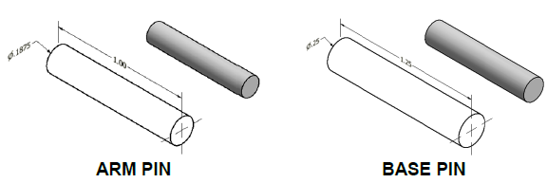

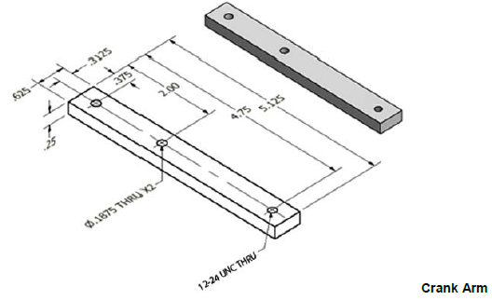

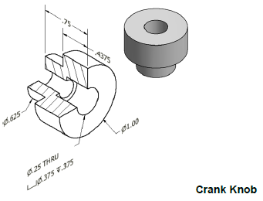
Create my profile without the hole, revolve it and then put the hole in.

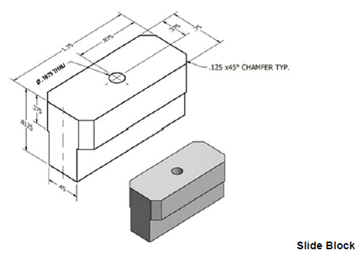
Before you place the hole, save me as two separate files, SlideBlock and ThreadedSlideBlock.

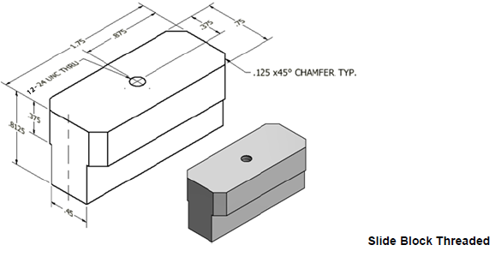
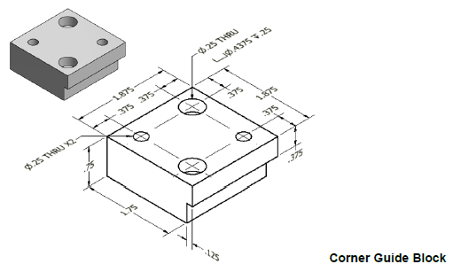
I have two sides that are cut back. They are next to each other not across from each other.
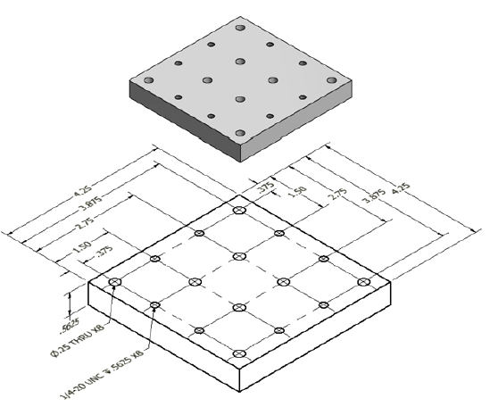Base Plate
Notice I have two different size holes. Dimension a point in a corner and then use the rectangular pattern tool to create the rest of the points. Then use the hole tool to create each hole

Drawing
Create a drawing of the Crank Arm. It must show the top, front, right and iso views, correctly dimensioned. Extra credit will be given if the hole sizes and types are shown as in the drawing above.

