Reverse Engineering Process
Final Project

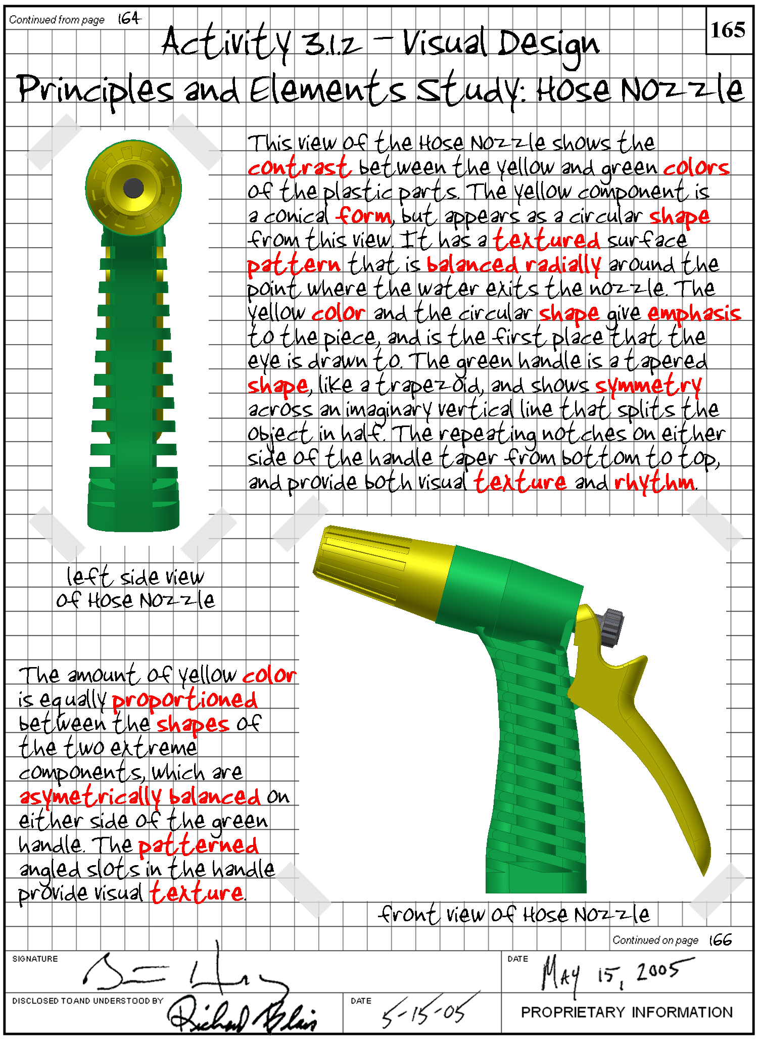
Visual Analysis

In this activity, working in a team of two or three, you will choose a relatively simple mechanical (non-electrical) product to reverse engineer, such as a hose nozzle. You will use a digital camera to aid you in your visual analysis of the object. Finally, you will describe the object using the language of visual design principles and elements.

Select the product or object for your study.

Perform a visual analysis of the object using the following procedure:
- In your engineering notebook, identify the product of your study, for example: Hose Nozzle.
- Using a digital camera, take at least three pictures of the product from different angles.
- Print out the images, and neatly secure them in your engineering notebook.
- Create a caption under each image that identifies the particular object view.
- Next to each image, write a description of the visual design principles and elements that are evident from that particular view.
- Submit your engineering notebook to your instructor for evaluation.

Functional Analysis
In this activity you will analyze the function of your consumer product.

Before measurement and dissection, you must theorize how the product functions through non-destructive observation. Identify your product’s name and the company that produced it, and answer the following questions in your engineering notebook.
Product Name:
Company Name:

- What is the purpose or primary function of the object?
- Sketch an isometric pictorial of the product in your engineering notebook and label the individual components. If you are not sure what a particular component is called, then make a logical guess.
- Make an educated guess as to how this product operates. Use simple machines’ terminology to explain the object’s sequential operation.
- Identify the system inputs, intended product function, and outputs in the table below.
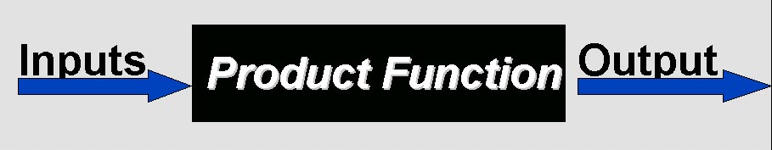
Inputs | Product Function | Output

- What mechanical components are visible?
- What is it about this device’s function that you cannot identify because the mechanical components are hidden from plain view?

Produce Disassembly
Carefully disassemble your product and identify each part by name, quantity, size, function, material, finish, interaction of parts, and general notes using the Product Disassembly Chart to record your work.

- Create pictorial sketches, as necessary, to communicate the internal operation of the product.
- Carefully measure each part using appropriate measuring devices.
- Create annotated sketches of each part including an isometric pictorial (at least) and orthographic projections (as necessary) to detail the part with dimensions, material, and other characteristics.
- Compare your hypothesis of the operation and function of your product to its actual operation. Document your findings.
Use resources available to you, such as the Internet, to help explain how your product operates.
How Stuff Works URL: www.HowStuffWorks.com
The New Way Things Work by David Macaulay
- Complete the Product Disassembly Chart to detail important aspects of each part.

Sample Annotated Sketch of Part Documentation
The following is an example of a part documentation using an isometric sketch with annotated notes of fillet, hole location, materials, finish part location, and interactive parts.

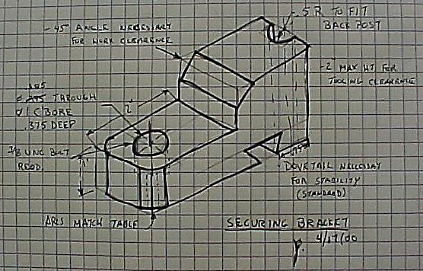

Final Product

Earlier you and team mate(s) examined the structural characteristics of your consumer product. You created a chart that identified the parts and measurements, and you created and gathered other important information, such as isometric sketches for each part and mass property analysis results. You will document and present the findings that resulted from your reverse engineering process.

- If you have not already done so, create an isometric sketch and quick orthographic projections of each part of your product. Note that these sketches are intended to provide a means to record dimensions and notes – they should be neat but not necessarily to scale. Measure each part then label and dimension the sketches. Be sure to annotate the sketches with all dimensions necessary to accurately model each part.
- Create a 3D solid model of each part of your consumer product. Discuss with your team mate(s) who will model each part. Also, determine to what degree of accuracy you will dimension the parts in the CAD software, what file name you will use to save each part model, where the files will be saved, and what part modeling procedures you will use. Communicate with your partner throughout this assignment so that both of you abide by the standards identified.
- Have your teacher check your progress and the modeling of your parts as you work.
- Perform a mass property analysis of each part using the 3D modeling software.
- Create a multi-view drawing for each part to include necessary orthographic projections and an isometric projection. You need only provide overall dimensions on the orthographic projections. You will create fully dimensioned part drawings in the next unit.
- According to the instructions of your teacher, create an electronic flyer/poster, or a slide show presentation that includes the following:
- Rendered isometric drawing with a title bar and notes showing the following information for each part of the product:
- Name of Part
- Overall Dimensions of Part
- Material of Part
- Density of Material
- Volume
- Surface Area
- Mass
- A photographic image of each part with a part label that corresponds to the drawing of each part
- A photographic image of the assembled product.
- A brief description of your findings during each phase of the reverse engineering process to include:
  - Visual Analysis. Include photographic images of various views and a description of the visual elements and principals of design.
  - Functional Analysis. Include an explanation of the operation of the product using photographic images or views of the part solid models where appropriate.
  - Structural Analysis. Include the Disassembly Chart.

