Unit 5: Exponential Functions
- Which of the following expressions is equivalent to $y=5x^{-4}$
a) $y=\frac{5}{x^{4}}$ b) $y=\frac{4}{x^{5}}$ c) $y=5x^{4}$ d) $y=\frac{1}{{5x}^{4}}$

- Simplify the expression $x^{3}x^{5}$
a) $x^{2}$ b) $x^{8}$ c) $x^{15}$ d) $x^{35}$

- Simplify the expression $\frac{3^{8}}{3^{4}}$
a) $3^{4}$ b) $3^{2}$ c) $1^{2}$ d) $1^{4}$

- ${\left(2a\right)}^{3}= ?$
a) $2a^{3}$ b) $5a^{3}$ c) $6a^{3}$ d) $8a^{3}$

- Simplify $\sqrt{50}$
a) $2\sqrt{5}$
b) $5\sqrt{2}$
c) $25\sqrt{2}$
d) $2\sqrt{25}$

- If a > 0, the graph for equation
y = a(0.87)^{x} will depict:
a) exponential growth
b) linear decay
c) linear growth
d) parabolic decay
e) exponential decay

- If b > 0, the graph for equation
y = b(3^{x}) will depict:
a) exponential growth
b) linear decay
c) linear growth
d) parabolic decay
e) exponential decay

Use for #8-10: The rule
$y=15,000({0.88}^{x})$ gives the value (in dollars) of a car that is x years old.
- What question can be answered by solving the equation $10,000=15,000({0.88}^{x})$?
a) What will be the value of the car after 10,000 years?
b) When will the value of the car equal $10,000?
c) When will the value of the car be less than $10,000?
d) When will the value of the car be greater than $10,000?
e) None of the above

- Which of the following statements describe how the value of the car changes from one year to the next?
As time passes, the value of the car …
a) increases at a slow rate
b) remains the same
c) increases at a constant rate
d) decreases at a rapid rate
e) decreases at a constant rate

- Evaluate $y=15,000({0.88}^{15})$. Round to the nearest dollar.
a) $198,000
b) $28,200
c) $7,916
d) $2,205
e) $1,163

Does the graph show an exponential growth or a linear growth?
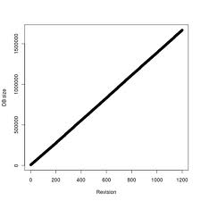  - __________________ | 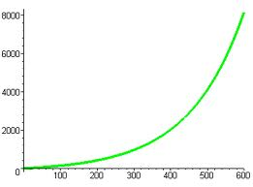  - __________________ | 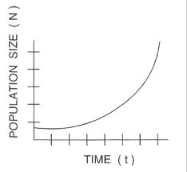  - __________________
Do the tables show an exponential growth or a linear growth?
- __________________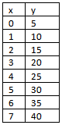 | - __________________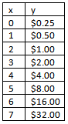 | - __________________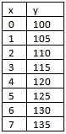
- In the table below:
- What is the y intercept? b. What is the growth factor?
- What equation fits this data? d. Graph the data on a coordinate plane.

X | Y
0 | 1
1 | 4
2 | 16
3 | 64
4 | 256

- If you invest $750 at a yearly interest rate of 7%:
- What is the growth factor?
- How much money will you have after 6 years?

- If you invest $50 at a yearly interest rate of 3%:
- What is the growth factor?
- How much money will you have after 10 years?

Evaluate.
- (-10)²=
- ${\left(-2\right)}^{3}$=
- ${\left(-2\right)}^{5}=$
- ${\left(-3\right)}^{2}=$

- You have a bag of 500 pieces of candy and you eat a third of the pieces a day.
- Create a table showing the candy remaining for days 0-8.
- What is the y-intercept?
- What is the decay factor?
- What equation matches this situation?

- You have another bag of candy with 700 pieces and you eat a fourth of the pieces a day.
- Create a table showing the candy remaining for days 0-8.
- What is the y-intercept?
- What is the decay factor?
- What equation matches this situatio

