CMIC 2 – Unit 3 Name: _________________________________
Size Transformations Unraveled

- On a coordinate grid, draw the following geometrical shape, $XYZ=\left[\begin{matrix}1 & 5 & 5 \\ 1 & 1 & 5\end{matrix}\right]$.

  - Add the following shape to the same graph in a different color, $X'Y'Z'=\left[\begin{matrix}2 & 10 & 10 \\ 2 & 2 & 10\end{matrix}\right]$.
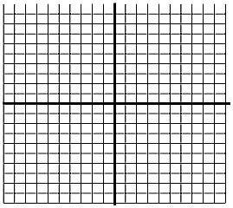
Pre-Image |  | Translation Image
X | (1, 1) | X′ | (2, 2)
Y | (5, 1) | Y’ | (10, 2)
Z | (5, 5) | Z’ | (10, 10)

To change from the pre-image to the translation image, create a coordinate rule by filling in the blanks.

(x, y) → (__x, __y)

- A size transformation (or dilation) of magnitude 3 centered at the origin is defined by the following rule:
$$\begin{matrix}preimage & & image \\ (x, y) & → & (3x, 3y)\end{matrix}$$
  - If all points are multiplied by 3 in this size transformation, what would be the matrix for the transformation?

$$ABCD=\left[\begin{matrix}\begin{matrix}1 & 3 \\ 2 & 1\end{matrix} & \begin{matrix}-1 & 1 \\ -2 & -3\end{matrix}\end{matrix}\right] → A^{'}B^{'}C^{'}D^{'}=\left[\begin{matrix}\begin{matrix} & \\ & \end{matrix} & \begin{matrix} & \\ & \end{matrix}\end{matrix}\right]$$

  - On the provided diagram, draw the image of quadrilateral ABCD under this size transformation.

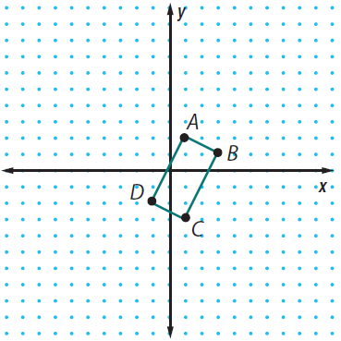
eri
c. Compare and contrast the following characteristics
between the preimage and image of the
quadrilateral.

Perimeter:

Area:

