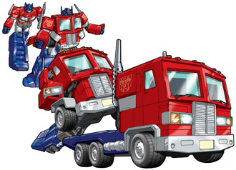
Transformation Rules

Line Reflections
Reflect over x-axis
$$\left(x, y\right)→(x, -y)$$
Reflect over y-axis
$$\left(x, y\right)→(-x, y)$$
Reflect over $y=x$
$$\left(x, y\right)→\left(y, x\right)$$
Reflect over $y=-x$
$$\left(x, y\right)→(-y, -x)$$

Rotations
$90° Rotation$
$$\left(x, y\right)→\left(-y, x\right)$$
$$180° Rotation$$
$$\left(x, y\right)→\left(-x, -y\right)$$
$$270° Rotation$$
$$\left(x, y\right)→\left(y, -x\right)$$
$$90° Counterclockwise Rotation$$
$$\left(x, y\right)→(y, -x)$$

Translation
Horizontal shift of a, Vertical shift of b
$$\left(x, y\right)→(x+a, y+b)$$

