U3L1I1 HW DUE: Thursday, September 12
1. | 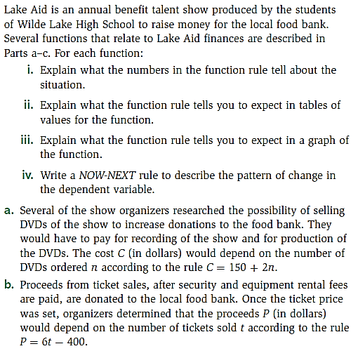 | 2. | 