CMIC 1 – Linear Functions without Context Name___________________________
U3L1I1c HW Date____________________________

For the following equations, fill in the table, graph the given function, write a NOW-NEXT rule and answer any additional questions. This is focusing on the relationships between tables of values, graphs and symbolic rules for linear equations.

1) | $$y=3x-4$$ |  | X -1 0 1 2 3 4  y |  | 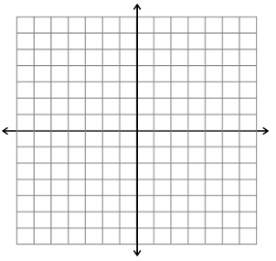
 |  |  | NOW-NEXT Rule:
 | - Label the coordinates of three points A, B and C on the graph. Calculate the slopes of the segments between points A and B, between points B and C, and between points A and C.
 |  | Slope between A and B: |  | Slope between B and C: |  | Slope between A and C:
 |  | $$\frac{∆y}{∆x}=$$ |  | $$\frac{∆y}{∆x}=$$ |  | $$\frac{∆y}{∆x}=$$

2) | $$y=\frac{1}{2}x+2$$ | X -1 0 1 2 3 4  y
 |  | NOW-NEXT Rule:
 | - Locate the y-intercept on the graph. What are the coordinates of the y-intercept for this equation?
3) Determine if the following situation is a linear relationship. Provide evidence of your thinking.
If a race car averages 150 miles per hour, the distance d covered is a function for driving time t.

U3L1I1 – CYU Handout Name:________________________________
Spring 1 | Spring 2
Coordinates of the y-intercept:

Slope of the line plotted:
Coordinates of the y-intercept:

Slope of the line plotted:
Spring 3 | Spring 4
Coordinates of the y-intercept:  Slope of the line plotted: | Coordinates of the y-intercept:  Slope of the line plotted:

