U3L1I2b HW DUE: Wednesday, September 18
1. | 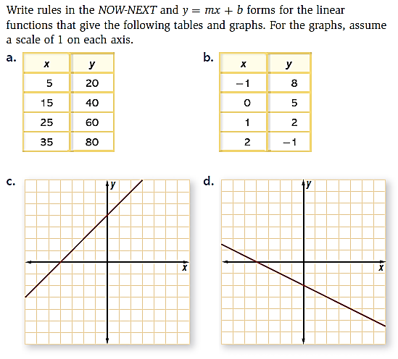
2. | 