U3L1I2c HW DUE: Thursday, September 19
1. | 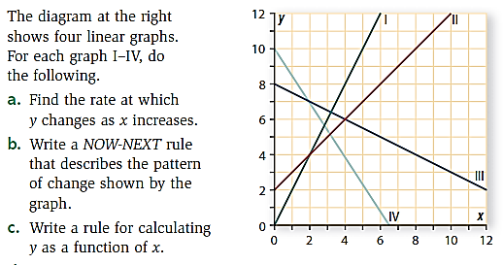
2. | 