U3L2I4 (b) HW DUE: Monday, September 23
1. | 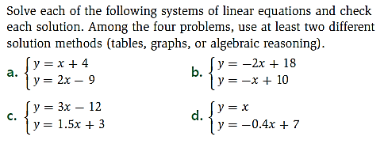
2. | 