U3L3I2(b) HW DUE: Monday, September 9
1. | 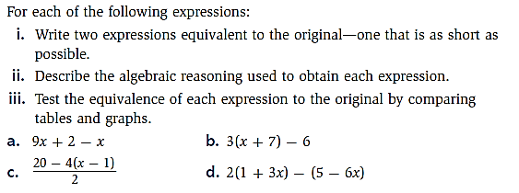
2. | 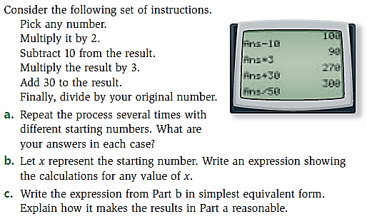
3. | 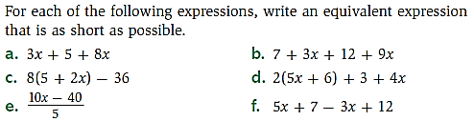
4. | 