U5L1I1 (b) HW DUE: Monday, September 30
1. | 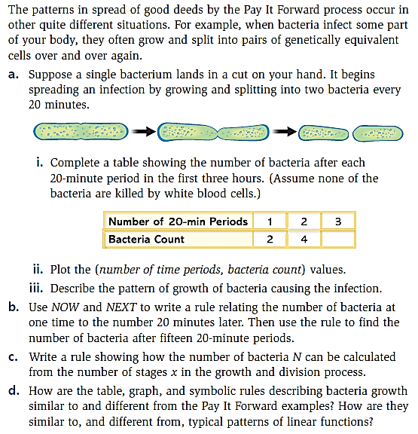
2. | 