U5L1I2 (a) HW DUE: Tuesday, October 1
1. | 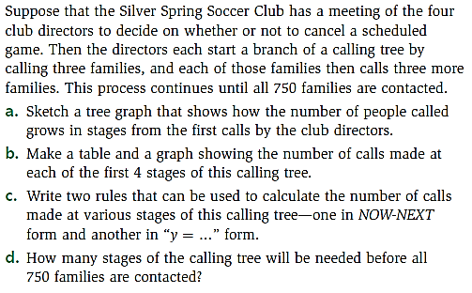
2. | 