U5L1I2 (b) HW DUE: Wednesday, October 2
1. | 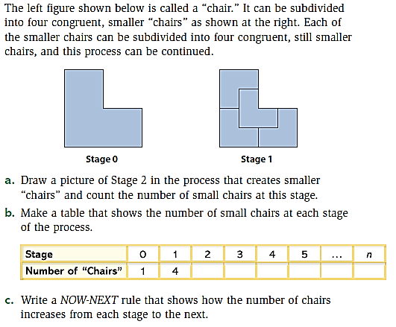 | 2. | 