U5L1I3 (a) HW DUE: Monday, October 7
1. | 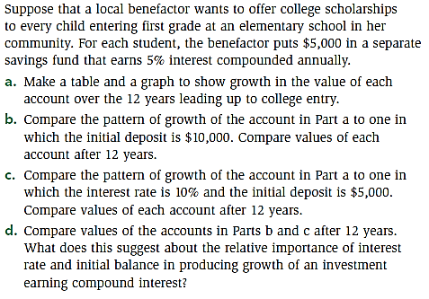 | 2. | 