U5L1I4b HW Due: Monday, April 14
1.

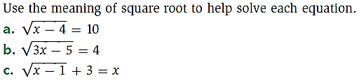
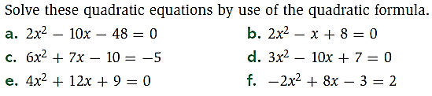
2.

