U5L2I2(a) HW DUE: Wednesday, October 9
1. | 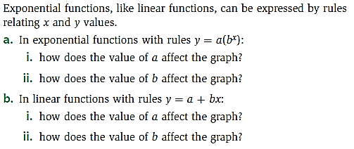 | 3. | 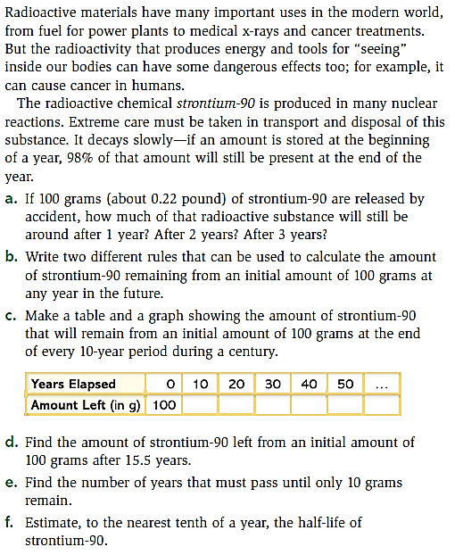
2. | 