U5L2I3(a) HW DUE: Thursday, October 10
1. | 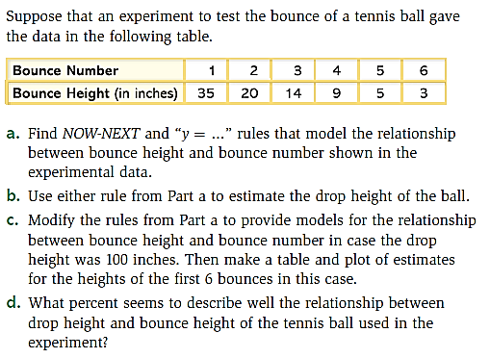 | 3. | 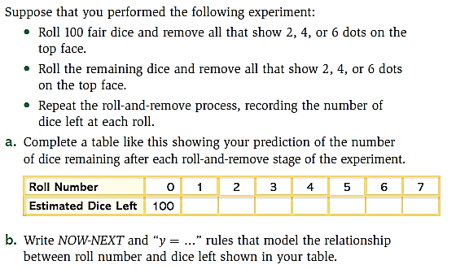
2. | 