U7L1I1(a) HW DUE: Wednesday, October 23
The equation used to model projectile motion is:

$$h=h_{0}+v_{0}t-16t^{2}$$

$h_{0}=$ Initial Height $v_{0}=$ Initial Velocity

1. | 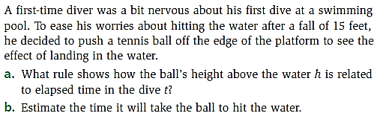 | 2. | 