U7L1I2(a) HW DUE: Wednesday, October 30
1. | 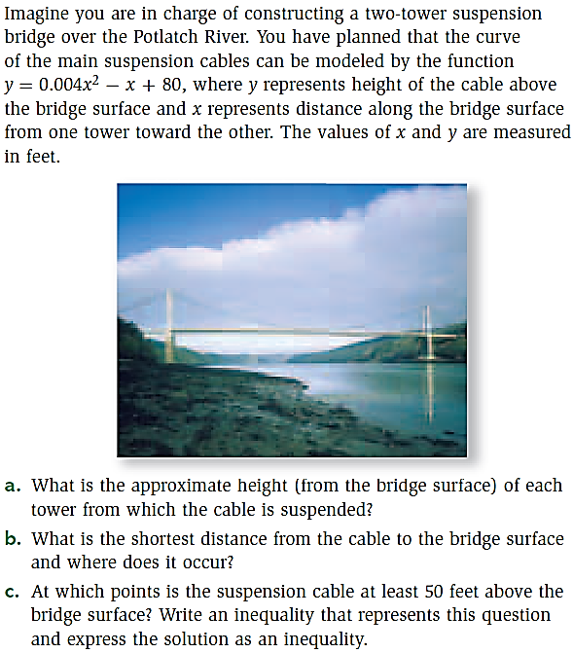 | 2. | 