U7L1I3(a) HW DUE: Thursday, October 31
1. | 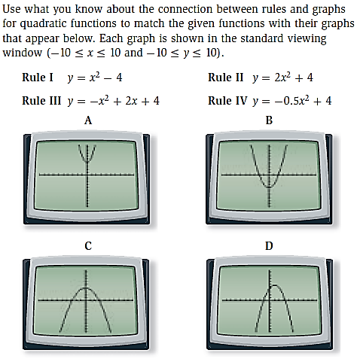 | 2. | 