IED Unit 3 Vocabulary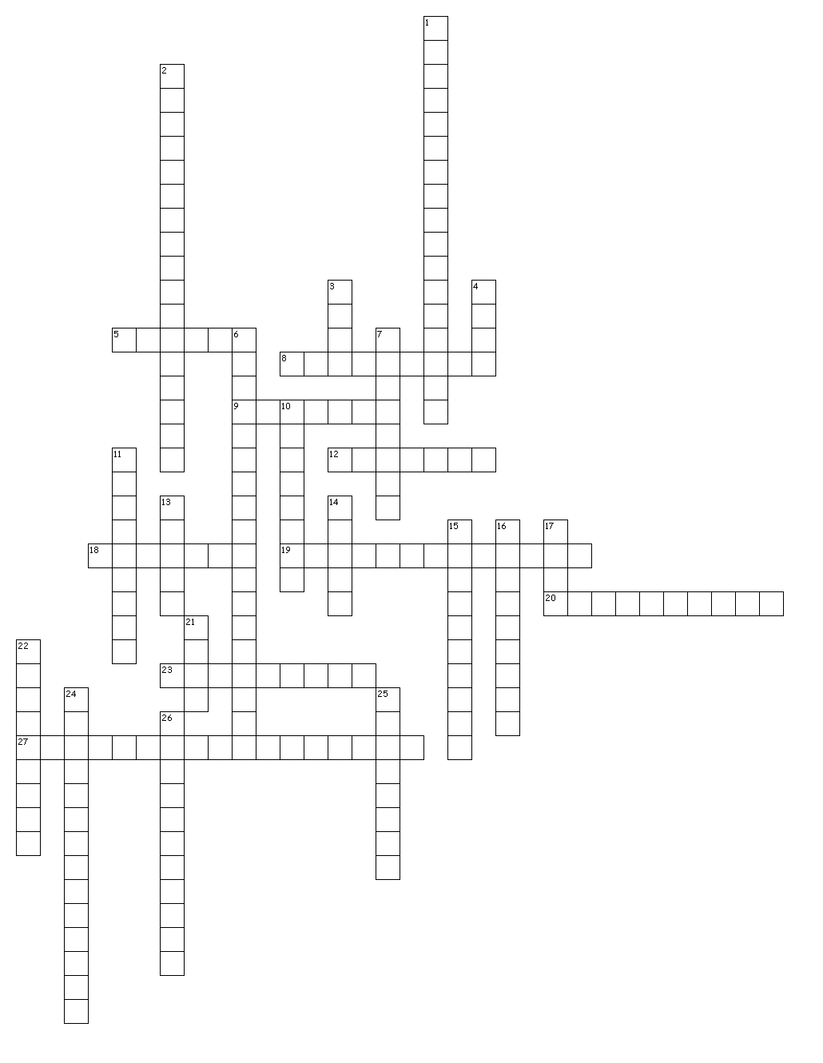

Across
5. A measure of center which is the center value of a sorted list.
8. The degree to which repeated measurements show the same result.
9. To determine the size, amount, or degree of an object by comparison with a standard unit.
12. A measuring instrument having two adjustable jaws typically used to measure diameter or thickness.
18. A group of individual values that are related in some way or have some common characteristic.
19. A group of values that is used to analyze the distribution of data.
20. Arrowheads are used to indicate the end of a dimension line or leader.
23. A graph of vertical bars representing the frequency of a set of data.
27. A number value or algebraic equation that is used to control the size or location of a geometric figure.

Down
1. The distance of a value in a population from the mean value of the population.
2. The digits in a decimal number that carry meaning contributing to the precision or accuracy of the quantity.
3. The value that occurs most frequently in a given data set.
4. A measure of center computed by adding the values in a list and then dividing by the number of values.
6. A function that represents the distribution of variables as a symmetrical bell-shaped graph.
7. A method of visually displaying data values where each data value is shown as a dot or mark above a number line.
10. The degree of closeness of measurements of a quantity to the actual value.
11. A change or slight difference in condition, amount, or level.
13. A diagram showing the relation between variable quantities.
14. A proportion between two sets of dimensions used in developing accurate, larger or smaller prototypes.
15. Collection of methods for planning experiments, obtaining data, organizing, summarizing, presenting, analyzing, interpreting, and drawing conclusions based on data.
16. The rate at which something occurs over a particular period.
17. Facts and statistics used for reference or analysis.
21. A standard quantity in terms of which other quantities may be expressed.
22. A distance such as width, height, and depth.
24. A line which represents distance.
25. To change money, stocks, or units in which a quantity is expressed into others of a different kind.
26. A graph in the coordinate plane representing a set of bivariate data.

